March 20th, 2022

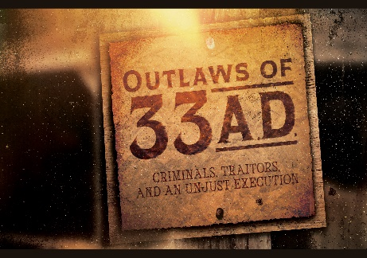
Week 3:
Barabbas:
The Price of Freedom

Mark 15:6-15

Matthew 27:15-26; Luke 23:18-25; John 18:40

- The _______ Scene
- Jesus was arrested in the ________ at night.

- Jesus’ three trials happened around ______.

- The crowd was made up mostly of Barabbas _______________.

- The crowd in this scene was not the same as the ______________ Entry.

- The chief priests and elders ________ the flame.

- Still, this was not a scene of ___________, it was a scene of what the __________ is.

- Barabbas the _____________
“Now, it was the custom at the festival to release a prisoner whom the people requested. A man called Barabbas was in prison with the insurrectionists who had committed murder in the uprising. The crowd came up and asked Pilate to do for them what he usually did.” Mark 15:6-8 (NIV)
- ________ Barabbas
“So, when the crowd had gathered, Pilate asked them, ‘Which one do you want me to release to you: Jesus Barabbas, or Jesus Who is called the Messiah?’” Matthew 27:17 (NIV)

- Barabbas was a patriot and _____.
“At that time they had a well-known prisoner whose name was Jesus Barabbas.” Matthew 27:16 (NIV)

- Barabbas was a _________.

- The two different Jesus _______________.
- Son of __ father - “Bar” Son of, and “abbas” father

- Son of ____ Father

- Pilate the _________________
“‘Do you want me to release to you the king of the Jews?’ asked Pilate, knowing it was out of self-interest that the chief priests had handed Jesus over to him. But the chief priests stirred up the crowd to have Pilate release Barabbas instead. ‘What shall I do, then, with the one you call the king of the Jews?’ Pilate asked them. ‘Crucify him!’ they shouted. ‘Why? What crime has he committed?’ asked Pilate. But they shouted all the louder, ‘Crucify him!’ Wanting to satisfy the crowd, Pilate released Barabbas to them. He had Jesus flogged and handed him over to be crucified.” Mark 15:9-15 (NIV)
- Pilate was ____ over the Jews in that region.

- Pilate knew Jesus was _____________.

- Pilate ___________ what he knew was right.

- _______________ leads to 3 tragedies:
- Compromise weakens ___________.
- Compromise means lack of _______.
- Compromise weakens ___________.
“Come near to God and He will come near to you.” James 4:8a (NIV)
- The ________ chose war over peace. Hate over love.
“If the world hates you, keep in mind that it hated Me first.” John 15:18 (NIV)

- We are all Barabbas
- Jesus knew His mission, do you?
“The Son of Man must suffer many things and be rejected by the elders and chief priests and scribes, and be killed, and on the third day be raised.” Luke 9:22 (NIV)

- Which Jesus will you choose?

- The Roman Road
- The human problem
“For all have sinned and fall short of the glory of God,” Romans 3:23 (NIV)
“For the wages of sin is death…” Romans 6:23a (NIV)

- The human hope
“But God demonstrates His own love for us in this: While we were still sinners, Christ died for us.” Romans 5:8 (NIV)

- The human response
“If you declare with your mouth, ‘Jesus is Lord,’ and believe in your heart that God raised Him from the dead, you will be saved. For it is with your heart that you believe and are justified, and it is with your mouth that you profess your faith and are saved.” Romans 10:9-10 (NIV)

d. The human salvation
“Therefore, there is now no condemnation for those who are in Christ Jesus,” Romans 8:1 (NIV)
“…but the gift of God is eternal life in Christ Jesus our Lord.” Romans 6:23b (NIV)

Bottom Line: We got what Jesus deserved. Jesus got what we deserved (the price of freedom).
To begin a relationship with Jesus…
Text: I Choose Jesus to 570-273-0088

Next Sunday:
Outlaws of 33A.D.:
Criminals, Traitors, and an Unjust Execution.
Week 4: Nicodemus


Giving and Attendance Update
Giving last Sunday: 95.1%
Giving year to date: 89.2%
Last Sunday’s attendance: 1,789
Salvations to date: 193/ Baptisms to date: 30

