January 2nd, 2022

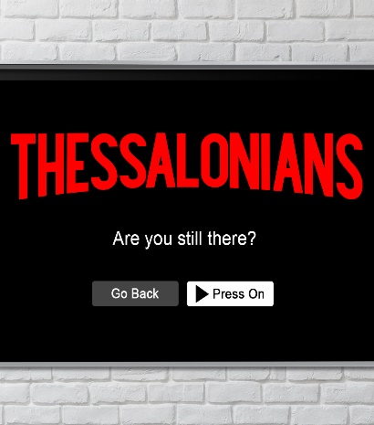

Week 1:
Are You Still Flourishing?

1 Thessalonians 1:1-10

- God’s Way to _________ the World
- The vitals of ___________________
- Written from Corinth in _______
- Written by the _______________
- Written to ______ believers

- The city of _________________
- The center of _______ (Alexandrian) influence
- A __________ pot of cultures

- The Church in Thessalonica (__________)
- Three weeks of ____________
- Paul ___________ out
- Left a strong, witnessing, and ________ church

- A Model of a ________ Church
“Paul, Silas, and Timothy, To the church of the Thessalonians in God the Father and the Lord Jesus Christ: Grace and peace to you. We always thank God for all of you and continually mention you in our prayers. We remember before our God and Father your work produced by faith, your labor prompted by love, and your endurance inspired by hope in our Lord Jesus Christ.” 1 Thessalonians 1:1-3 (NIV)

- The first ____________ church greeting
- Grace (Greek: ___________)
- Peace (Jewish: __________)

- A new ___________
“The Church became a spiritual life and bond which attracts and unites people of different races, backgrounds, and temperaments to a unique and vital fellowship or community.” The Wesleyan Bible Commentary

- Three great _________ of the Christian life
- Work ___________ by faith
“Servants, do what you’re told by your earthly masters. And don’t just do the minimum that will get you by. Do your best. Work from the heart for your real Master, for God, confident that you’ll get paid in full when you come into your inheritance. Keep in mind always that the ultimate Master you’re serving is Christ. The sullen servant who does shoddy work will be held responsible. Being a follower of Jesus doesn’t cover up bad work.” Colossians 3:23 (MSG)
- Labor __________ by love
- Endurance ___________ on hope

“Faith goes up the stairs that love has built and looks out the windows which hope has opened.” A New Covenant Commentary

- A Model of a _________ Church
“For we know, brothers and sisters loved by God, that He has chosen you, because our gospel came to you not simply with words but also with power, with the Holy Spirit and deep conviction. You know how we lived among you for your sake. You became imitators of us and of the Lord, for you welcomed the message in the midst of severe suffering with the joy given by the Holy Spirit. And so you became a model to all the believers in Macedonia and Achaia. The Lord’s message rang out from you not only in Macedonia and Achaia—your faith in God has become known everywhere.” 1 Thessalonians 1:4-8b (NIV)

- A chosen church knows it’s about the Message, not the ______________.
“If the world hates you, keep in mind that it hated me first.” John 15:18 (NIV)

- A chosen church is an example of _________________.

- A chosen church’s witness is the ________.

“They tell how you turned to God from idols to serve the living and true God, and to wait for His Son from heaven, whom He raised from the dead—Jesus, who rescues us from the coming wrath.” 1 Thessalonians 1:9b-10 (NIV)

- The church is a _________ of God’s love.

- While we wait, ____________.

- What do we do about it?
- Be known for flourishing.

- Have a hopeful faith.
Faith rooted in the right motive will persevere under pressure. It will also fail with lesser motives.

- Preach joy.

To begin a relationship with Jesus…
Text: I Choose Jesus to 570-273-0088

Next Sunday:
Thessalonians: Are You Still There?
Week 2: Are You Still Fervent?
(1 Thessalonians 2)

Giving & Attendance Update
Giving last Sunday: 67.8% of goal
Giving year to date: 88.5% of goal
Attendance last Sunday: 1,150
Salvations to date: 176 | Baptisms to date: 25

Christmas Blessing Update
Local: $36,794.11
Global (Clean Water): $43,557.46

