December 5th, 2021
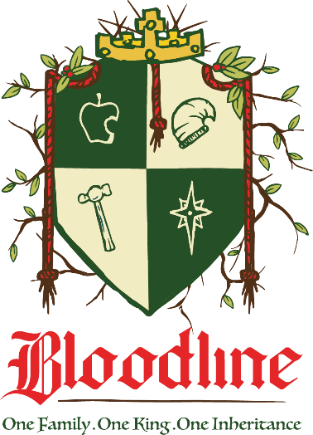

Week 2: Abraham and Isaac: The Inheritance of a Perfected Faith

Genesis 22:12-18

- When we withhold, we _________.
“‘Do not lay a hand on the boy,’ He said. ‘Do not do anything to him. Now I know that you fear God, because you have not withheld from Me your son, your only son.’” Genesis 22:12 (NIV)
- We ______ what God can do.

- We ______ what we can do.

- We ______what future generations can do.

- When we trust, we ________.
“Abraham looked up and there in a thicket he saw a ram caught by its horns. He went over and took the ram and sacrificed it as a burnt offering instead of his son. So, Abraham called that place The Lord Will Provide. And to this day it is said, ‘On the mountain of the Lord it will be provided.’” Genesis 22:13-14 (NIV)
- We ________ God to provide.

- We ________ ourselves to be blessed.

- We _______ future generations to be blessed.

“Often there are believers who wonder how they may know the will of God. We believe that ninety percent of the knowing of the will of God consists in willingness to do it before it is known.” (Barnhouse)

- ___________ in the home of Abraham
“The angel of the Lord called to Abraham from heaven a second time and said, ‘I swear by Myself, declares the Lord, that because you have done this and have not withheld your son, your only son, I will surely bless you and make your descendants as numerous as the stars in the sky and as the sand on the seashore. Your descendants will take possession of the cities of their enemies, and through your offspring all nations on earth will be blessed, because you have obeyed Me.’” Genesis 22:15-18 (NIV)
- ____________ and God
- A __________ made and kept.
- The _______
- The ___________ descendants
- The ______ of Christmas.

- _______ and Mary
- Isaac means ___________.
“Sarah said, ‘God has brought me laughter, and everyone who hears about this will laugh at me.’” Genesis 21:6 (NIV)
- The womb ____________
“‘How will this be,’ Mary asked the angel, ‘since I am a virgin?’” Luke 1:34 (NIV)

- _________ and Jesus
- Both were ________ by their father.
- Both __________ themselves willingly.
- Both _________ wood up the hill for their sacrifice.
- Both were _____________ from death on the third day.
“On the third day Abraham looked up and saw the place in the distance.” Genesis 22:4 (NIV)
“…that Christ died for our sins according to the Scriptures, that He was buried, that He was raised on the third day according to the Scriptures…” 1 Corinthians 15:3b-4 (NIV)

- What do we do about it?
- Believe it. Have faith in Him.

- Know that God has called us into the fellowship with His suffering.

- How often a human heart falls short in fellowship with God at the point of suffering.
- We leave the world.
- We follow His method.
- We patiently wait through the darkness.
- We rejoice in hope.
- We gather, pray, and bring our questions.
- At the point of suffering, we withhold.

Why couldn’t our obedience in trusting when trusting is hard, be as impactful to future generations as it was with Abraham’s obedience?

To begin a relationship with Jesus…
Text: I Choose Jesus to 570-273-0088

Next Sunday: Week 3: Rahab: The Inheritance of a Perfected Purpose
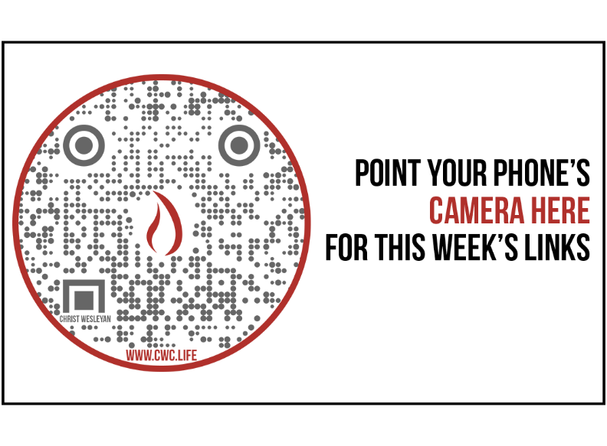
World Religion Map
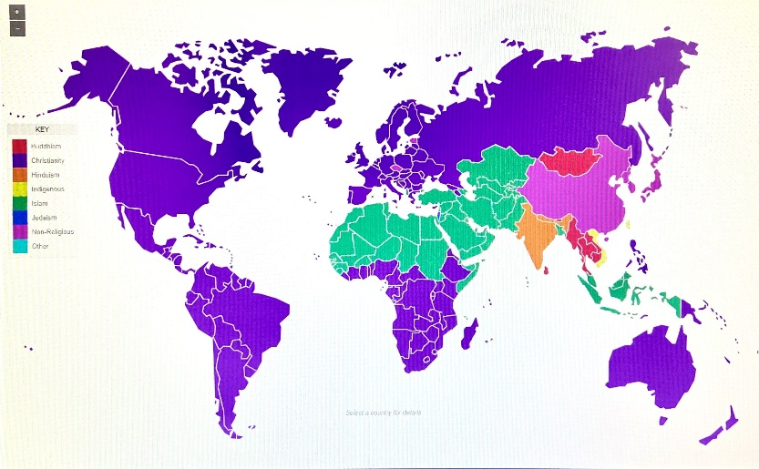
Source: https://wvia.pbslearningmedia.org/resource/sj14-soc-religmap/world-religions-map/

Giving & Attendance Update
Giving last Sunday: 54.5% of goal
Giving year to date: 87.8% of goal
Attendance last Sunday: 1,722
Salvations to date: 164 | Baptisms to date: 26

