August 29th, 2021


Week 5: Give Eternally

Matthew 6:19-24

- A Choice: Earth or _________?
“Do not store up for yourselves treasures on earth, where moths and vermin destroy, and where thieves break in and steal. But store up for yourselves treasures in heaven, where moths and vermin do not destroy, and where thieves do not break in and steal.” Matthew 6:19-20

- _______ Riches (clothes, cars, money, toys, houses, fame, power, profession)
- ____________
- _________

- ___________ Riches (blameless life, forgiveness of sins, wisdom, the Holy Spirit, eternal inheritance, souls)
- __________
- _______

- A Choice: Bad or Good ________?
“For where your treasure is, there your heart will be also.
The eye is the lamp of the body. If your eyes are healthy, your whole body will be full of light. But if your eyes are unhealthy, your whole body will be full of darkness. If then the light within you is darkness, how great is that darkness!” Matthew 6:21-23 (NIV)
- A _____ Heart
- _________
- ____________

- A _______ Heart
- ______
- __________

- A Choice: Materialism or ______?
“No one can serve two masters. Either you will hate the one and love the other, or you will be devoted to the one and despise the other. You cannot serve both God and money.” Matthew 6:24 (NIV)

1. The master of _______________
a. Earthly riches are not a sign that one is godly.
b. You might be a ____________ if…
a) You curse out your _________ when the stock market crashes.
b) You check the ____ before you check the Word.
c) You fear ______ more than you fear godliness.
d) You value _____________ more than service to others.

- The Master of _____________…
- Offers freedom from _________.
“Therefore I tell you, do not worry about your life…” Matthew 6:25a (NIV)

- Offers joy and ________________.
- Offers ___________ and eternal life.

- So now what?
- Where do I start?
- Pray
- The paper in front of you
- The back of this outline

- How can I give my time and talents?
- Write out your schedule
- Talk with your family
- Contact a ministry leader

- How can I give of my resources?
- Does my giving line up with what I treasure?
- How much do I want God to bless?

To begin a relationship with Jesus…
Text: I Choose Jesus to 88202

Next Sunday: All-In: Don’t just go to church, be the church-Go Make Disciples
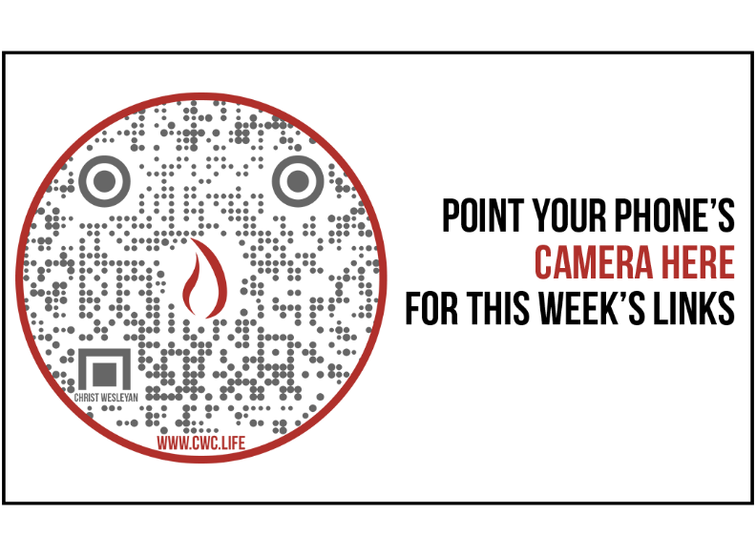

20 Reasons Why It Is More Blessed to Give Than to Receive by Jayson D. Bradley (January 2021)
1. GIVING IS HOW GOD DEMONSTRATES HIS LOVE FOR US
John 3:16 is one of the most well-known verses of all time. It says, “For God so loved the world, that He gave His only Son, that whoever believes in Him should not perish but have eternal life.”
2. GIVING MAKES YOU HAPPY
3. GIVING COMMUNICATES SOMETHING IMPORTANT ABOUT OUR WORLDVIEW
Psalm 50:10 says, “For every beast of the forest is Mine, the cattle on a thousand hills.” This beautifully reveals the sovereignty of God and His ultimate ownership of every resource.
4. GIVING IS THE WAY GOD BLESSES OTHERS
5. GIVING HELPS US LIVE LONGER
The journal Health Psychology published a study in 2012 that found that people who regularly volunteer live longer. But there was a catch—it had to be for unselfish reasons.
If you volunteered for any reason beyond the joy of giving, it didn’t have the same long-term health benefits.
6. GIVING JOYFULLY MAKES GOD HAPPY
7. GIVING INCREASES OUR SOCIAL CONNECTEDNESS
8. GIVING IS AN ACT OF OBEDIENCE
9. GIVING IS CONTAGIOUS

In a combined study between the University of California, San Diego, and Harvard, the first laboratory evidence was found that showed how cooperative behavior is infectious. It spreads through social networks.

10. GIVING GIVES YOUR LIFE MEANING
It isn’t until you become generous that you can say that giving is important to you. Once you do, you’ll find that it begins to define you more profoundly than you previously thought possible.
11. GIVING BATTLES DEPRESSION
12. GIVING PUTS GOD IN OUR DEBT
The writer of Proverbs says it in even more emphatic language, “Whoever is generous to the poor lends to the Lord, and He will repay him for his deed” (Prov. 19:17). God in your debt. Ponder that a second.
13. GIVING INCREASES OUR CONFIDENCE
14. GIVING BUILDS TRUST
15. GIVING MAKES YOU LISTEN DIFFERENTLY
Generous people tend to listen to people’s stories with the question, “Is there a way I can help?” The more they give, the more they hear a need or request behind someone’s story.
16. GIVING MAKES YOU LOOK AT YOUR RESOURCES DIFFERENTLY
17. GIVING GENERATES CONTENTMENT
18. GIVING PROMOTES A UNIVERSAL GOOD
19. GIVING HELPS CREATE LASTING RELATIONSHIPS
20. GIVING MAKES YOU LIKEABLE

