February 21, 2021
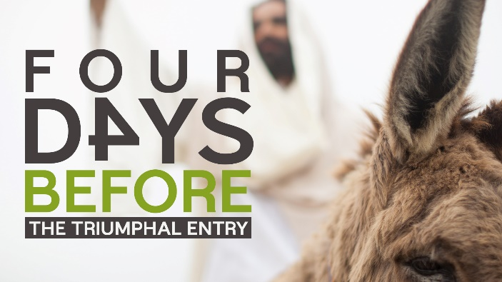

“Rejoice greatly, Daughter Zion. Shout, Daughter Jerusalem!
See, your king comes to you, righteous and victorious, lowly and riding on a donkey, on a colt, the foal of a donkey. Zechariah 9:9 (NIV)
When Jesus comes to town, things get stirred!

- Prophecy
- More than five hundred years earlier, God had revealed to the prophet Daniel that the Messiah would come 483 years after the command would be given to rebuild Jerusalem (Daniel 9:25).
- The command to rebuild Jerusalem was given by King Artaxerxes of Persia, in the month of Nisan in the twentieth year of his reign (Nehemiah 2:1–6).
- The Jews did not use a solar calendar as we do today, and in biblical prophecies, the years are composed of 360 days (Revelation 11:2–3; 12:6).
- The exact day of the month is not given; but if the command to rebuild Jerusalem was given on the first of Nisan, March 5, 444 BC, it was 483 years of 360 days later—to the day—that Jesus entered Jerusalem on March 30, AD 33, the day of His formal entry into the city as Messiah.
B. Moments

1. The moment
“As He approached Bethphage and Bethany at the hill called Mount of Olives, He sent two of His disciples, saying to them, ‘Go to the village ahead of you, and as you enter it, you will find a colt tied there, which no one has ever ridden. Untie it and bring it here.’” Luke 19:29-30 (NIV)

2. The moment
“They brought it to Jesus, threw their cloaks on the colt and put Jesus on it. As He went along, people spread their cloaks on the road. When He came near the place where the road goes down the Mount of Olives, the whole crowd of disciples began joyfully to praise God in loud voices for all the miracles they had seen: ‘Blessed is the King who comes in the name of the Lord! Peace in Heaven and glory in the highest.’” Luke 19:35-38

C. Moments

1. The moment
“Some of the pharisees in the crowd said to Jesus, ‘Teacher, rebuke your disciples!’ ‘I tell you,’ He replied, ‘if they keep quiet, the stones will cry out.’” Luke 19:39-40 (NIV)

2. The moment
“As He approached Jerusalem and saw the city, He wept over it and said, ‘If you, even you, had only known on this day what would bring you peace—but now it is hidden from your eyes. The days will come upon you when your enemies will build an embankment against you and encircle you and hem you in on every side. They will dash you to the ground, you and the children within your walls. They will not leave one stone on another, because you did not recognize the time of God’s coming to you.’” Luke 19:41-44 (NIV)

a. ___________

b. ___________

c. ___________

D. A Moment
“When Jesus entered Jerusalem, the whole city was stirred and asked, ‘Who is this?’ The crowds answered, ‘This is Jesus, the prophet from Nazareth in Galilee.’” Matthew 21:10-11

1. A stirred life

2. A stirred Church

3. A stirred city

To begin a relationship with Jesus…
Text: I Choose Jesus to 88202
A New Series: The Final 24
February 28: The Last Supper (Matthew 26-20-30; Mark 14:17-26; Luke 22:14-38; John 13:21-30)

The Triumphal Entry
Matthew 21:1-11, Mark 11:1-11, Luke 19:28-44 John 12:12-19 (ESV)
The next day the large crowd that had come to the feast heard that Jesus was coming to Jerusalem. As they drew near to Jerusalem, to Bethpage and Bethany, at the Mount of Olives, Jesus sent two of His disciples and said to them, “Go into the village in front of you, and immediately as you enter it you will find a donkey tied, and a colt with her, on which no one has ever sat. Untie it and bring it. If anyone says to you, ‘Why are you doing this?’ say, ‘The Lord has need of it and will send it back here immediately.'”
And they went away and found a colt tied at a door outside in the street, and they untied it. This took place to fulfill what was spoken by the prophet, saying, “Say to the daughter of Zion, ‘Behold, your king is coming to you, humble, and mounted on a donkey, on a colt, the foal of a beast of burden.'”
And some of those standing there said to them, “What are you doing, untying the colt?”
And they told them, “The Lord has need of it.”
And they brought the colt to Jesus and threw their cloaks on it, and He sat on it. And many spread their cloaks on the road, and others spread leafy branches that they had cut from the fields. As He was drawing near–already on the way down the Mount of Olives–the whole multitude of His disciples began to rejoice and praise God with a loud voice for all the mighty works that they had seen, saying, “Blessed is the King who comes in the name of the Lord! Peace in heaven and glory in the highest!”
And those who went before and those who followed were shouting, “Hosanna! Blessed is He who comes in the name of the Lord! Blessed is the coming kingdom of our father David! Hosanna in the highest!”.
Now, when He drew near and saw the city, He wept over it, saying, “Would that you, even you, had known on this day the things that make for peace! But now they are hidden from your eyes. For the days will come upon you, when your enemies will set up a barricade around you and surround you and hem you in on every side and tear you down to the ground, you and your children within you. And they will not leave one stone upon another in you, because you did not know the time of your visitation.”
When He entered Jerusalem, the whole city was stirred up, saying, “Who is this?”
And the crowds said, “This is the prophet Jesus, from Nazareth of Galilee.”
His disciples did not understand these things at first, but when Jesus was glorified, then they remembered that these things had been written about Him and had been done to Him. The crowd that had been with Him when He called Lazarus out of the tomb and raised him from the dead continued to bear witness. The reason why the crowd went to meet Him was that they heard He had done this sign. So, the Pharisees said to one another, “You see that you are gaining nothing. Look, the world has gone after him.”
And some of the Pharisees in the crowd said to Him, “Teacher, rebuke your disciples.”
He answered, “I tell you, if these were silent, the very stones would cry out.”
And when He had looked around at everything, as it was already late, He went out to Bethany with the twelve.

