September 2, 2018

“Empowered: The Church on Fire!”
“A Journey through the Book of Acts”
“A Fire That Carries You Through Storms”
“For the next two years, Paul lived in Rome at his own expense.
He welcomed all who visited him, boldly proclaiming the Kingdom of God and teaching about the Lord Jesus Christ.
And no one tried to stop him.” Acts 28:30-31

- Paul’s to Rome...
“When the time came, we set sail for Italy. Paul and several other prisoners were placed in the custody of a Roman officer named Julius, a captain of the Imperial Regiment. Aristarchus, a Macedonian from Thessalonica, was also with us.” Acts 27:1-2a
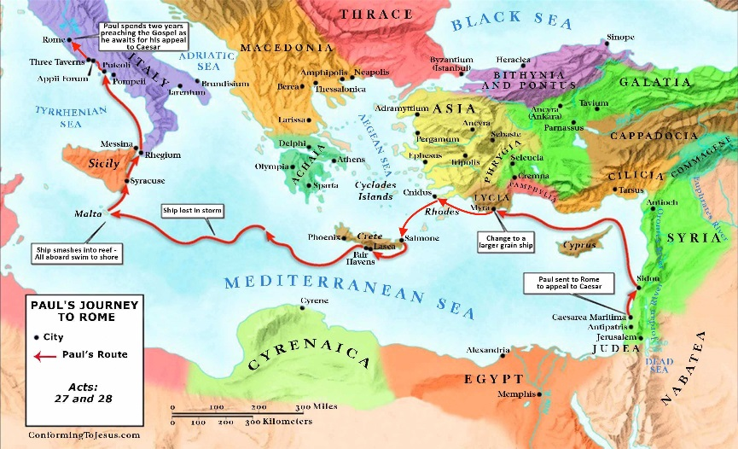
- Paul left Caesarea with coworkers, Aristarchus and Luke.
“Aristarchus, who is in prison with me, sends you his greetings…” Colossians 4:10
- Julius was kind to Paul when they at Sidon.
“The next day when we docked at Sidon, Julius was very kind to Paul and let him go ashore to visit with friends so they could provide for his needs.” Acts 27:3
- Paul landed at Myra and changed .
“…landing at Myra, in the province of Lycia. There the commanding officer found an Egyptian ship from Alexandria that was bound for Italy, and he put us on board.” Acts 275b-6
- The weather was battling against them and they docked at Havens.
“We struggled along the coast with great difficulty and finally arrived at Fair Havens, near the town of Lasea.” Acts 27:8
- Paul gave to the ship’s officers.
“ ‘Men,’ he said, ‘I believe there is trouble ahead if we go on—shipwreck, loss of cargo, and danger to our lives as well.’” Acts 27:10
- The officer listened to the ship’s captain, the that Fair Havens was an exposed harbor, the crew’s opinion, and the fact that Phoenix was a good harbor.
“But the officer in charge of the prisoners listened more to the ship’s captain and the owner than to Paul.” Acts 27:11
- A came upon them suddenly.
“But the weather changed abruptly, and a wind of typhoon strength (called a ‘northeaster’) burst across the island and blew us out to sea.” Acts 27:14
- The strengthened, the crew began throwing cargo overboard, the ship’s gear and lost all hope.
“The terrible storm raged for many days, blotting out the sun and the stars, until at last all hope was gone.” Acts 27:20
- Paul gave to the crew!
“But take courage! None of you will lose your lives, even though the ship will go down. For last night an angel of the God to whom I belong and whom I serve stood beside me, and he said, ‘Don’t be afraid, Paul, for you will surely stand trial before Caesar! What’s more, God in his goodness has granted safety to everyone sailing with you.’ So take courage! For I believe God. It will be just as he said. But we will be shipwrecked on an island.” Acts 27:22-26
- The crew was to abandon ship and Paul warned them again.
“But Paul said to the commanding officer and the soldiers, ‘You will all die unless the sailors stay aboard.’ So the soldiers cut the ropes to the lifeboat and let it drift away.” Acts 27:31-32
- Paul encouraged the crew to as they had not eaten in two weeks.
“Please eat something now for your own good. For not a hair of your heads will perish.” Acts 27:34
- They cut off the anchors and the ship ran aground. All the crew made it to shore.
“So everyone escaped safely to shore.

- Paul on the Island of Malta before arriving in Rome…
“Once we were safe on shore, we learned that we were on the island of Malta.” Acts 28:1
- Publius, the chief official of the welcomed Paul and the crew. Paul heals Publius’s father and others.
“As a result we were showered with honors, and when the time came to sail, people supplied us with everything we would need for the trip.” Acts 28:10
- months later, they set sail for Rome and stopped at Syracuse for three days.
“It was three months after the shipwreck that we set sail on another ship…” Acts 28:11
- They stopped at Rhegium for a and sailed to Puteoli for a week, spending time with believers.
“ From there we sailed across to Rhegium...so the following day we sailed up the coast to Puteoli.” Acts 28:13
- Paul believers when he landed in Rome at the Appian Way and The Three Taverns.
“The brothers and sisters in Rome…came to meet us at the Forum on the Appian Way…at The Three Taverns. When Paul saw them, he was encouraged and thanked God.” Acts 28:15
- While in Rome, Paul had his own private lodging with a . Paul shared the gospel with all that he could and there he wrote his prison letters, Ephesians, Philippians, Colossians, and Philemon.
“When we arrived in Rome, Paul was permitted to have his own private lodging, though he was guarded by a soldier.” Acts 28:16

- Facing the storms in life…
“We have this hope as an anchor for the soul, firm and secure.” Hebrews 6:19a NIV
- Being in God’s will does not mean we will be exempt from storms. We will face storms.
- It’s not logic that gets us through the storms, but the calming presence of God’s Spirit that is always with us.
- There may come a time, in the midst of the storm, when you feel hopeless. Remember you are not alone.
- God’s promises are always our anchor. We cannot trust our feelings. We have to trust His promises!
- We need each other especially when in the storms. Don’t pull away but lean into the strength He provides through the body of Christ. Encourage one another.
- Your storms become your testimony and the source of growth as your roots go deep!
- Don’t let the storms sidetrack you from God’s plan and purpose! He has even greater things He will do if your trust is in Him.
“That is what the Scriptures mean when they say, ‘No eye has seen, no ear has heard, and no mind has imagined what God has prepared
for those who love him.’” 1 Corinthians 2:9

