July 29, 2018

“Empowered: The Church on Fire!”
“A Journey through the Book of Acts”
“Paul Is Tested in the Fire”
“But he said, ‘Why all this weeping? You are breaking my heart! I am ready not only to be jailed at Jerusalem but even to die for the sake of the Lord Jesus.’” Acts 21:13

- Finishing the mission trip...
“After saying farewell to the Ephesian elders, we sailed straight to the island of Cos.” Acts 21:1
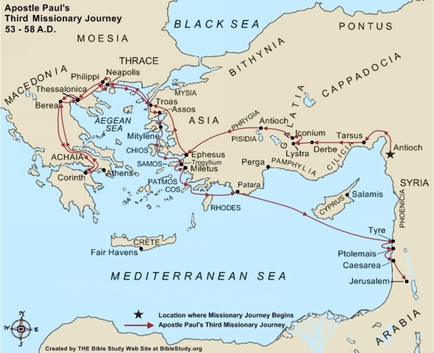
- Paul and his companions traveled to .
- The next day they reached and Patara. Rhodes was the home of The Colossus, one of the Seven Wonders of the Ancient World! It was a 108-foot statue of the Greek god Helios, on a 50-foot white marble platform.
- They boarded a ship sailing for Phoenicia, past Cyprus.
- They landed at in Syria where he found believers and stayed with them for a week.
- They boarded a and traveled to Ptolemais and stayed one day.

- The next day they traveled to Caesarea and stayed with Philip the Evangelist and his daughters.
- After days, they packed and went to Jerusalem. There, they met with James and all of the elders of the Jerusalem church.
“The next day Paul went with us to meet with James, and all the elders of the Jerusalem church were present. After greeting them, Paul gave a detailed account of the things God had accomplished among the Gentiles through his ministry.” Acts 21:18-19

- Paul encounters a lot of ...
- Paul left the Ephesian with tears.
“After saying farewell to the Ephesian elders…” Acts 21:1
- Paul the believers in Tyre where they prophesied that he should not go to Jerusalem.
“There we knelt, prayed, and said our farewells.” Acts 21:5b-6a
- In Caesarea, Agabus prophesied of Paul’s desperate encounter that would be ahead in Jerusalem. The believers him not to go.
“When we heard this, we and the local believers all begged Paul not to go on to Jerusalem.” Acts 21:12
- Paul gave a detailed to the elders and responded to their concerns about Jewish laws.
“Then everyone will know that the rumors are all false and that you yourself observe the Jewish laws.” Acts 21:24b
- After seven days, a was aroused and the whole city was in an uproar.
“The whole city was rocked by these accusations, and a great riot followed. Paul was grabbed and dragged out of the Temple, and immediately the gates were closed behind him.” Acts 21:30
- Paul requested to speak to the . He shared his testimony. Acts 22:1-21
“Please, let me talk to these people.” Acts 21:39b
- Paul revealed his citizenship to the commander.
“Is it legal for you to whip a Roman citizen who hasn’t even been tried?” Acts 22:25b
- Paul appeared before the council of Sadducees and Pharisees. They became divided by Paul’s declaration of his belief in the resurrection of the dead.
“As the conflict grew more violent, the commander was afraid they would tear Paul apart. So he ordered his soldiers to go and rescue him by force and take him back to the fortress.” Acts 23:10

- Paul’s (his sister’s son) heard of the plot to kill Paul by more than 40 men.
“The next morning a group of Jews got together and bound themselves with an oath not to eat or drink until they had killed Paul.” Acts 23:12
- The commander moved Paul to by sending him to Governor Felix in Caesarea.
“Then the commander called two of his officers and ordered, ‘Get 200 soldiers ready to leave for Caesarea at nine o’clock tonight. Also take 200 spearmen and 70 mounted troops. Provide horses for Paul to ride, and get him safely to Governor Felix.’” Acts 23:23-24

- How do we know when it is God’s will or not? How do we discover God’s will?
- First, surrender to His will.
“And so, dear brothers and sisters, I plead with you to give your bodies to God because of all He has done for you. Let them be a living and holy sacrifice—the kind He will find acceptable. This is truly the way to worship him. Don’t copy the behavior and customs of this world, but let God transform you into a new person by changing the way you think. Then you will learn to know God’s will for you, which is good and pleasing and perfect.” Romans 12:1-2
- Obey what you know to be God’s command.
“And we can be sure that we know Him if we obey his commandments. If someone claims, ‘I know God,’ but doesn’t obey God’s commandments, that person is a liar and is not living in the truth. But those who obey God’s word truly show how completely they love Him. That is how we know we are living in Him. Those who say they live in God should live their lives as Jesus did.” 1 John 2:3-6
- Trust God to show you His will.
“Teach me to do your will, for you are my God. May your gracious Spirit lead me forward on a firm footing.” Psalm 143:10
- Live a life of gratefulness.
“Be thankful in all circumstances, for this is God’s will for you who belong to Christ Jesus.” 1 Thessalonians 5:18
- Let your life show Christ.
“It is God’s will that your honorable lives should silence those ignorant people who make foolish accusations against you.” 1 Peter 2:15
- Look at your gifts and see how God can use them.
“God has given each of you a gift from His great variety of spiritual gifts. Use them well to serve one another.” I Peter 4:10

- Learn to listen and recognize God’s voice.
“My sheep listen to My voice; I know them, and they follow Me.” John 10:27
- Delight in Him and commit your way to Him.
“Take delight in the Lord, and He will give you your heart’s desires. Commit everything you do to the Lord. Trust Him, and He will help you.” Psalm 37:4-5
- Seek godly counsel.
“Without wise leadership, a nation falls; there is safety in having many advisers.” Proverbs 11:14
- Look for open and closed doors.
“When I came to the city of Troas to preach the Good News of Christ, the Lord opened a door of opportunity for me.” 2 Corinthians 2:12

Want to take this message deeper?
Want to dive deeper in thought and application?
Go to our podcast on iTunes or our website at:
www.cwc.life/dive-deep

