July 22, 2018

“Empowered: The Church on Fire!”
“A Journey through the Book of Acts”
“Taking the Fire to the People: Part 2”
“So the message about the Lord spread widely and had a powerful effect.” Acts 19:20

- Paul on the third mission trip...
“When the uproar had ended, Paul sent for the disciples and, after encouraging them, said goodbye and set out for Macedonia.”
Acts 20:1
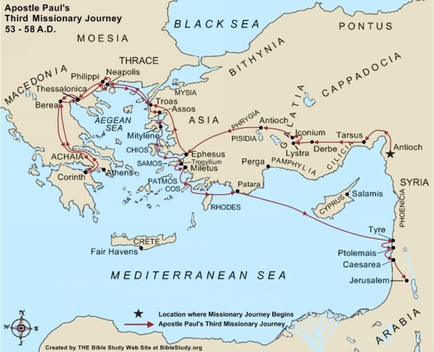
- Paul continued to Greece and stayed for months. It is believed he wintered in Corinth when travel was difficult. While in Corinth, he wrote Romans.
- It is believed he set sail for to celebrate Passover in Jerusalem, but due to the threats, he headed over by land. He had to readjust his schedule to Pentecost rather than Passover.
- He was accompanied by a of traveling companions: Sopater from Berea, Aristarchus and Secundus from Thessalonica, Gaius from Derbe, Timothy and Tychicus from Trophimus in Asia.
- The group went ahead and they all met at . Troas was a large Roman colony and 10-15 miles south of the site of the Trojan Wars. It was the best harbor in the region and very prosperous.

- Eutychus, the ...
“Seated in a window was a young man named Eutychus, who was sinking into a deep sleep as Paul talked on and on.” Acts 20:9a
- Paul preached until midnight and many were lit.
- Eutychus fell asleep and fell out of the third story window.
- Paul stopped preaching long enough to bring him back from the dead, grab a to eat, and then preached till morning.
“The people took the young man home alive and were greatly comforted.” Acts 20:12

- Paul’s to the Ephesian Elders…
“Paul had decided to sail past Ephesus to avoid spending time in the province of Asia, for he was in a hurry to reach Jerusalem, if possible, by the day of Pentecost.” Acts 20:16
- Paul the elders of the importance of a lifestyle that supports the message of the gospel.
“You know how I lived the whole time I was with you, from the first day I came into the province of Asia.” Acts 20:18b
- A lifestyle must serve with . Humility is a life yielded to God, submissive to God, and indebted to all people.
“I served the Lord with great humility…” Acts 20:19a
- A lifestyle would include . Paul felt intensely about the work or reaching others with the gospel.
“…and with tears…” Acts 20:19b
- A lifestyle will include . Everyone who seeks to serve God will face opposition.
“and in the midst of severe testing by the plots of my Jewish opponents.” Acts 20:19c
- A message of should accompany this lifestyle--courage that is willing to offer truth.
“You know that I have not hesitated to preach anything that would be helpful to you but have taught you publicly and from house to house.” Acts 20:20
- Paul’s heart was compelled by the in spite of what he might face!
“I only know that in every city the Holy Spirit warns me that prison and hardships are facing me. However, I consider my life worth nothing to me; my only aim is to finish the race and complete the task the Lord Jesus has given me—the task of testifying to the good news of God’s grace.” Acts 20:23-24
- Paul discharged the message.
“Therefore, I declare to you today that I am innocent of the blood of any of you.” Acts 20:26
- Paul gave the of those who would divide.
“Keep watch over yourselves and all the flock of which the Holy Spirit has made you overseers. Be shepherds of the church of God… I know that after I leave, savage wolves will come in among you and will not spare the flock. Even from your own number men will arise and distort the truth in order to draw away disciples after them. So be on your guard!” Acts 20:28-31a
- Paul reassured them of his and his model of care before they prayed together. They wept and went with him to the ship.
“When Paul had finished speaking, he knelt down with all of them and prayed. They all wept as they embraced him and kissed him. What grieved them most was his statement that they would never see his face again. Then they accompanied him to the ship.” Acts 20:36-38

D. Thoughts to ponder…
- Paul originally thought he would make it to Jerusalem by Passover but had to change his plans to Pentecost. How do you handle changes in your plans?
- Paul’s message took the highest priority…nothing kept him from sharing the truth! Do you have a passion to share your joy and peace with others?
- Paul’s lifestyle backed up his message. Would others be open to hearing your testimony based on your life?
- Paul’s served with humility! Are you fully yielded to God, submissive to His will, and grateful to all who have impacted your life?
- Paul’s passion brought him to tears. When was the last time you had tears over those who were lost in your world…other than your family?
- Serving God will always have trials. What is your attitude toward the setbacks that come to you?
- Paul was willing to face whatever was before him. His deep love for God had brought him to the place where nothing mattered more than his faith! Have you come to the place where you are fully surrendered to His will…whatever that may be?
“I once thought these things were valuable, but now I consider them worthless because of what Christ has done. Yes, everything else is worthless when compared with the infinite value of knowing Christ Jesus my Lord. For His sake I have discarded everything else, counting it all as garbage, so that I could gain Christ.”
Philippians 3:7-8

