July 15, 2018

“Empowered: The Church on Fire!”
“A Journey through the Book of Acts”
“Taking the Fire to the People: Part 1”
“So the message about the Lord spread widely and had a powerful effect.” Acts 19:20

- Paul’s mission trip...
“While Apollos was in Corinth, Paul traveled through the interior regions until he reached Ephesus, on the coast, where he found several believers.” Acts 19:1
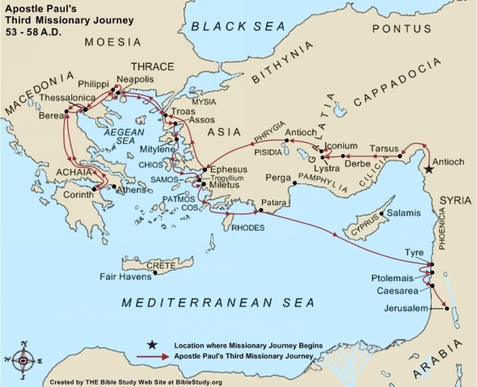
- Paul’s third mission trip is in Acts 18:24-21:14.
- The missionary journey took place around A.D.
- The total travel would have been about miles.
- The travel time would have taken about days.
- The travel would have been on both foot and ship. The total cost would have been more than .
- to leaving on his third journey, Paul wrote to the church in Thessalonica, both 1 & 2 Thessalonians.
- While Paul was on this journey, he wrote New Testament letters: 1 & 2 Corinthians, Galatians, and Romans.
“This went on for the next two years, so that people throughout the province of Asia—both Jews and Greeks—heard the word of the Lord.” Acts 19:10

- The Pentecost...
“On the day of Pentecost all the believers were meeting together in one place.” Acts 2:1
- Acts 2, Acts 10, and Acts 19 all report a type of Pentecost. All three Pentecosts had the same verbiage, the same experiences, and the same results…greater
to the body of Christ!
“And everyone present was filled with the Holy Spirit…” Acts 2:4a
- Acts 2 was a Pentecost to , more than 15 different languages. Acts 10 was a Pentecost to Gentiles, opening new doors to believing Gentiles. Acts 19 was a Pentecost to unite all the different segments of followers!
“As soon as they heard this, they were baptized in the name of the Lord Jesus. Then when Paul laid his hands on them, the Holy Spirit came on them, and they spoke in other tongues (or other languages) and prophesied.” Acts 19:5-6
- Once again, God powerfully united the of Christ!
“Paul said, ‘John’s baptism called for repentance from sin. But John himself told the people to believe in the one who would come later, meaning Jesus.’” Acts 19:4

- The battle in Ephesus…
“Outside of Christ, I am weak; in Christ, I am strong. Outside of Christ, I cannot; in Christ, I am more than able. Outside of Christ, I have been defeated; in Christ, I am already victorious. How meaningful are the words, in Christ.” –Watchman Nee
God scored a powerful victory through Paul in Ephesus!
- Paul went to the synagogue and preached boldly for
months.
“Then Paul went to the synagogue and preached boldly for the next three months, arguing persuasively about the Kingdom of God.” Acts 19:8
- Paul then held daily discussions for years.
“Then he held daily discussions at the lecture hall of Tyrannus. This went on for the next two years, so that people throughout the province of Asia—both Jews and Greeks—heard the word of the Lord.” Acts 9b-10
- God gave unusual to perform miracles for Paul.
“God gave Paul the power to perform unusual miracles. When handkerchiefs or aprons that had merely touched his skin were placed on sick people, they were healed of their diseases, and evil spirits were expelled.” Acts 19:11-12

- Some even tried to reproduce the power without !
“But one time when they tried it, the evil spirit replied, ‘I know Jesus, and I know Paul, but who are you?’ Then the man with the evil spirit leaped on them, overpowered them, and attacked them with such violence that they fled from the house, naked and battered.” Acts 19:15-16
- Many became believers and gave up all evidences of their past lives by destroying the evidence.
“Many who became believers confessed their sinful practices. A number of them who had been practicing sorcery brought their incantation books and burned them at a public bonfire. The value of the books was several million dollars. So the message about the Lord spread widely and had a powerful effect.” Acts 19:18-20
The enemy battled back in Ephesus!
- When all seemed peaceful, serious trouble .
“About that time, serious trouble developed in Ephesus concerning the Way.” Acts 19:23
- One , Demetrius the silversmith, stirs other artisans against Paul and the believers.
“It began with Demetrius, a silversmith who had a large business manufacturing silver shrines of the Greek goddess Artemis. He kept many craftsmen busy.” Acts 19:24
- Soon the whole city was in an !
“Soon the whole city was filled with confusion. Everyone rushed to the amphitheater, dragging along Gaius and Aristarchus, who were Paul’s traveling companions from Macedonia.” Acts 19:29
- It was a mentality with many not even knowing why they were there!
“Inside, the people were all shouting, some one thing and some another. Everything was in confusion. In fact, most of them didn’t even know why they were there.” Acts 19:32
- The was able to bring reason to the crowd and he dismissed them!
“Then he dismissed them, and they dispersed.” Acts 19:41

E. What understanding do we gain from this chapter?
- Always be prepared…when God scores a great victory, the enemy will seek to destroy! It may come emotionally, it may come through temptation, it may come through friends, and it may come in unexpected ways!

- Don’t rely on your own power or persuasive speech to make the difference!
“We use God’s mighty weapons, not worldly weapons, to knock down the strongholds of human reasoning and to destroy false arguments.” 2 Corinthians 10:4
- Realize that God has plenty of time to accomplish His work…and it may take time for God to work in and through you! Paul had daily discussions for two years.
- God will equip us with all we need to share the gospel with others. He cares more about their salvation than any of us possibly could!
- Don’t ever go against the enemy without being adequately prepared!
“And my message and my preaching were very plain. Rather than using clever and persuasive speeches, I relied only on the power of the Holy Spirit.” 1 Corinthians 2:4
- To gain complete victory in your life, you must get rid of all temptation or evidence of past temptations.
- It only takes one divisive person to create a division among believers, so protect yourself and the body of Christ by how you respond to divisive words.
- Continue to trust God to bring peace out of chaos- God will use a variety of sources or people to bring peace!
“But thank God! He gives us victory over sin and death through our Lord Jesus Christ.” 1 Corinthians 15:57

“Prayer is repeating the Victor’s Name, Jesus, into the ears of Satan and insisting on his retreat.” S.D. Gordon

Want to take this message deeper?
Want to dive deeper in thought and application?
Go to our podcast on iTunes or our website at:
www.cwc.life/dive-deep

