July 1, 2018

“Empowered: The Church on Fire!”
“A Journey through the Book of Acts”
“Rekindling the Flame”
“We believe that we are all saved the same way, by the undeserved grace of the Lord Jesus.” Acts 15:11

- The at Jerusalem...
“While Paul and Barnabas were at Antioch of Syria, some men from Judea arrived and began to teach the believers: ‘Unless you are circumcised as required by the law of Moses, you cannot be saved.’” Acts 15:1
- Paul and Barnabas came into a debate with these false teachers.
- A began to happen within the church between the Jews. Paul and Barnabas were sent to Jerusalem.
- Peter testified once again and recaptured the of the gospel.
“We believe that we are all saved the same way, by the undeserved grace of the Lord Jesus.” Acts 15:11
- This message would have to be recaptured and again!
“Then fourteen years later I went back to Jerusalem again, this time with Barnabas; and Titus came along, too. I went there because God revealed to me that I should go. While I was there I met privately with those considered to be leaders of the church and shared with them the message I had been preaching to the Gentiles. I wanted to make sure that we were in agreement, for fear that all my efforts had been wasted and I was running the race for nothing. And they supported me and did not even demand that my companion Titus be circumcised, though he was a Gentile.
Even that question came up only because of some so-called believers there—false ones, really—who were secretly brought in. They sneaked in to spy on us and take away the freedom we have in Christ Jesus. They wanted to enslave us and force us to follow their Jewish regulations. But we refused to give in to them for a single moment. We wanted to preserve the truth of the gospel message for you. And the leaders of the church had nothing to add to what I was preaching. (By the way, their reputation as great leaders made no difference to me, for God has no favorites.) Instead, they saw that God had given me the responsibility of preaching the gospel to the Gentiles, just as he had given Peter the responsibility of preaching to the Jews. For the same God who worked through Peter as the apostle to the Jews also worked through me as the apostle to the Gentiles. In fact, James, Peter, and John, who were known as pillars of the church, recognized the gift God had given me, and they accepted Barnabas and me as their co-workers. They encouraged us to keep preaching to the Gentiles, while they continued their work with the Jews. Their only suggestion was that we keep on helping the poor, which I have always been eager to do.” Galatians 2:1-10

- James, the leader of the Jerusalem Church and half-brother of , writes a letter to the Gentile believers and sends it back with the two teams of Paul and Barnabas, and Judas and Silas.
- Paul and Barnabas separate over and form new missionary teams: one team, Paul and Silas and the second team, Barnabas and John Mark.
“He made no distinction between us and them, for he cleansed their hearts through faith. So why are you now challenging God by burdening the Gentile believers with a yoke that neither we nor our ancestors were able to bear?” Acts 15:9-10

- The letter with four restrictions...
“And so my judgment is that we should not make it difficult for the Gentiles who are turning to God. Instead, we should write and tell them to abstain from eating food offered to idols, from sexual immorality, from eating the meat of strangled animals, and from consuming blood. For these laws of Moses have been preached in Jewish synagogues in every city on every Sabbath for many generations.” Acts 15:19-21
- All four of these restrictions were a part of pagan practices and .
- Food to idols – One God!
- Sexual immorality – Abstinence and purity!
- Strangled animals – Pagan practice!
- Blood – Pagan practice!
- The restrictions were meant to harmony between Jews and Gentiles.
- The restrictions were meant to peace and defer to other convictions.
- They were not given as a means to salvation, that was only by grace through faith!

- The second missionary journey…
“So Barnabas and Saul were sent out by the Holy Spirit.” Acts 13:4a
- This missionary journey took place around AD with Paul, Silas, Luke, and Timothy.
- The total travel would have been about miles.
- The travel time would have taken about days.
- The travel would have been both on foot and ship. The total cost would have been more than .

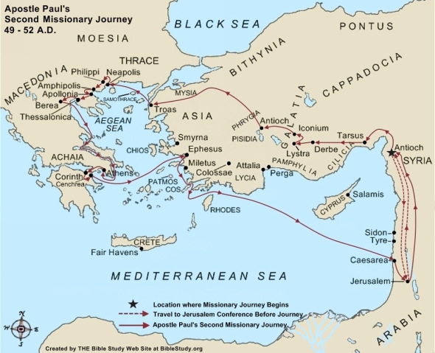
D. Missions with a challenge…
- Paul went to Derbe and Lystra and met with
Timothy. Timothy then accompanied them on their journey. Timothy had a respected testimony. Timothy’s mother was and his father, Greek. He was circumcised before traveling with them.
- Next, Paul and Silas traveled through Phrygia and Galatia. They then traveled to .
- Traveling to they stayed in Philippi for several days. There they saw the conversion and baptism of Lydia and her household.
- Paul and Silas were dragged before the city officials by an angry mob. They were and arrested.
- While in prison, they were singing hymns and praying while other prisoners listened. An earthquake set them all free.
- The jailer came to and all his family were baptized.
- Paul and Silas were released but they refused to go quietly as they were citizens and had been mistreated.
“When Paul and Silas left the prison, they returned to the home of Lydia. There they met with the believers and encouraged them once more. Then they left town.” Acts 16:40

E. Questions to consider…
- When Paul and Barnabas encountered those who were spreading another gospel, they disagreed “vehemently.” How should we handle disagreements with other believers? When should we dig in and when should we agree to disagree?
- The Council at Jerusalem gave four restrictions. Timothy chose to be circumcised, even though it was not a requirement. When should we defer to the convictions of others and when should we hold fast to our own? What sacrifices are you willing to make? How far should we go in preserving our witness?
- Paul listened to the Spirit in direction as to when and where he should travel. How do you listen to the Spirit’s voice as you seek direction? How does He guide you in your daily life?
- Paul and Silas were Roman citizens but were not treated fairly. When should we stand up for our rights and when should we be silent? How should we respond to the challenges to our faith today?
- Paul and Silas continued to face setbacks in their journey. Physical beatings, challenges to their travel, and opposition were continually before them. How do you keep your fire burning in your heart when you face disappointments, opposition, or setbacks?

“ So the churches were strengthened in their faith and grew larger every day.” Acts 16:5

Want to take this message deeper?
Want to dive deeper in thought and application?
Go to our podcast on iTunes or our website at:
www.cwc.life/dive-deep

