June 24, 2018

“Empowered: The Church on Fire!”
“A Journey through the Book of Acts”
“Fanning the Flame”
“One day as these men were worshiping the Lord and fasting, the Holy Spirit said, ‘Appoint Barnabas and Saul for the special work to which I have called them.’” Acts 13:2

- The first trip...
“So after more fasting and prayer, the men laid their hands on them and sent them on their way. So Barnabas and Saul were sent out by the Holy Spirit.” Acts 13:3-4a
- This missionary journey took place around AD with Paul, Barnabas, and John Mark.
- The total travel would have been about miles.
- The travel time would have taken about days.
- The travel would have been both on foot and ship. The total cost would have been more than .
“Finally, they returned by ship to Antioch of Syria, where their journey had begun. The believers there had entrusted them to the grace of God to do the work they had now completed.” Acts 14:26

- John Mark was their ...
“John Mark went with them as their assistant.” Acts 13:5b
- John Mark was the of Barnabas.
- John Mark was the of the Gospel of Mark, written a few years after this missionary trip.
- John Mark did not continue with them very long on this trip. He them after leaving the Island of Cyprus and landing in Perga.
“Paul and his companions then left Paphos by ship for Pamphylia, landing at the port town of Perga. There John Mark left them and returned to Jerusalem.” Acts 13:13
- Paul sees John Mark’s leaving as . This later created a disagreement between Paul and Barnabas that later separated their missionary journeys.
“But Paul disagreed strongly, since John Mark had deserted them in Pamphylia and had not continued with them in their work. Their disagreement was so sharp that they separated. Barnabas took John Mark with him and sailed for Cyprus.” Acts 15:38-39
- Later Paul recognized him as a .
“So do Mark, Aristarchus, Demas, and Luke, my co-workers.” Philemon 1:24
- Paul even recognized that John Mark was not only a co-worker but would be !
“Only Luke is with me. Bring Mark with you when you come, for he will be helpful to me in my ministry.” 2 Timothy 4:11

- The visited on the missionary journey…
“So Barnabas and Saul were sent out by the Holy Spirit.” Acts 13:4a
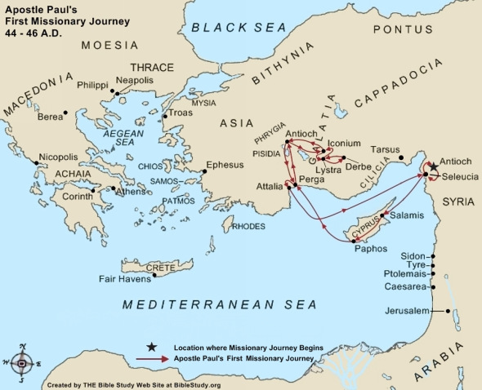
- Their first town was Salamis on the Island of .
Cyprus was about 100,000 people and considered very
wealthy. They preached in the Jewish synagogues.
“There, in the town of Salamis, they went to the Jewish synagogues and preached the word of God.” Acts 13:5
- Their next notable was Paphos. There they met
the false prophet, Bar-Jesus. (Bar in Aramaic was son, Ben in Hebrew was son.) Sergius Paulus was an intelligent man and the governor. He wanted to hear the Word of God. He became a believer with significant influence.
“Afterward they traveled from town to town across the entire island until finally they reached Paphos, where they met a Jewish sorcerer, a false prophet named Bar-Jesus.” Acts 13:6
- They traveled by to Perga in Pamphylia (modern Turkey). Perga was a large city of around 100,000. There John Mark left them. They traveled uphill about 100 miles to Pisidia, a city of about 100,000 as well. Paul’s first recorded sermon was then given. The sermon gave a history of the Jewish people and their rejection of Jesus. That sermon went well. They were begged to come for a return message the following week. It didn’t go so well the second time around. There were many converts but a mob ran them out of town.
“Then the Jews stirred up the influential religious women and the leaders of the city, and they incited a mob against Paul and Barnabas and ran them out of town.” Acts 13:50
- The same thing happened in Iconium. Paul’s powerful message converted many but many leaders poisoned the minds of others. The people were divided. Once again, a mob planned on attacking and stoning Paul and Barnabas.
“Then a mob of Gentiles and Jews, along with their leaders, decided to attack and stone them. When the apostles learned of it, they fled to the region of Lycaonia—to the towns of Lystra and Derbe and the surrounding area. And there they preached the Good News.” Acts 14:5-7
- Paul and Barnabas to Lystra and Derbe and preached there. They did miracles and healed a man who was crippled. The town proclaimed them as gods, Barnabas as Zeus and Paul as Hermes. The same story, there were many jealous leaders who incited a mob to attach them and stone them.
“Then some Jews arrived from Antioch and Iconium and won the crowds to their side. They stoned Paul and dragged him out of town, thinking he was dead. But as the believers gathered around him, he got up and went back into the town. The next day he left with Barnabas for Derbe.” Acts 14:19-20
- After preaching in Derbe and making many disciples, Paul and Barnabas returned to Lystra, Iconium and Pisidia, and Perga to and encourage believers. They appointed elders for each church.
“Finally, they returned by ship to Antioch of Syria, where their journey had begun. The believers there had entrusted them to the grace of God to do the work they had now completed.” Acts 14:26

- Points to ponder…
There was no mission plan to reach the world, before Paul and Barnabas and their missionary journey. Paul’s letters, 13 out of 29 books in the New Testament, were all birthed out of these missionary journeys. In fact, within 2 ½ centuries, Christianity had become the dominant religion in the Roman Empire. God had a plan!
- God always has a plan! It may face difficulty but don’t ever lose sight of God’s plan. Elymas tried to get in the way of the plan…but God’s plan went forward. Ultimately, nothing will stop God’s plan!
He will use fasting and prayer…
join the plan!
He will use willing vessels to share the Word…
be available!
He will use empowered servants to accomplish His will…
keep faithful!
He will make this happen! God’s got this!
- What if Barnabas had not been the encourager that he was? What would have happened to John Mark? What if Barnabas wasn’t willing to stand by his convictions? How did God use all of that? Can Christians disagree? Can they both be right?
- What if Paul and Barnabas saw every difficulty as God’s direction to turn back? What if they used all their circumstances to determine their decision? What would have been the outcome? What are the precautions that we all need to have in regard to the interpretation of circumstances?

“Upon arriving in Antioch, they called the church together and reported everything God had done through them and how he had opened the door of faith to the Gentiles, too.” Acts 14:27

Want to take this message deeper?
Want to dive deeper in thought and application?
Go to our podcast on iTunes or our website at:
www.cwc.life/dive-deep

