September 3, 2017
“Jesus and a Few Friends”
“Now you are my friends, since I have told you
everything the Father told me.” John 15:15b
“When a Friendship Goes Bad:
Friends Aren’t Always Forever- Judas!”
“Jesus responded, ‘It is the one to whom I give the bread I dip in the bowl.’ And when he had dipped it, he gave it to Judas, son of Simon Iscariot.” John 13:26

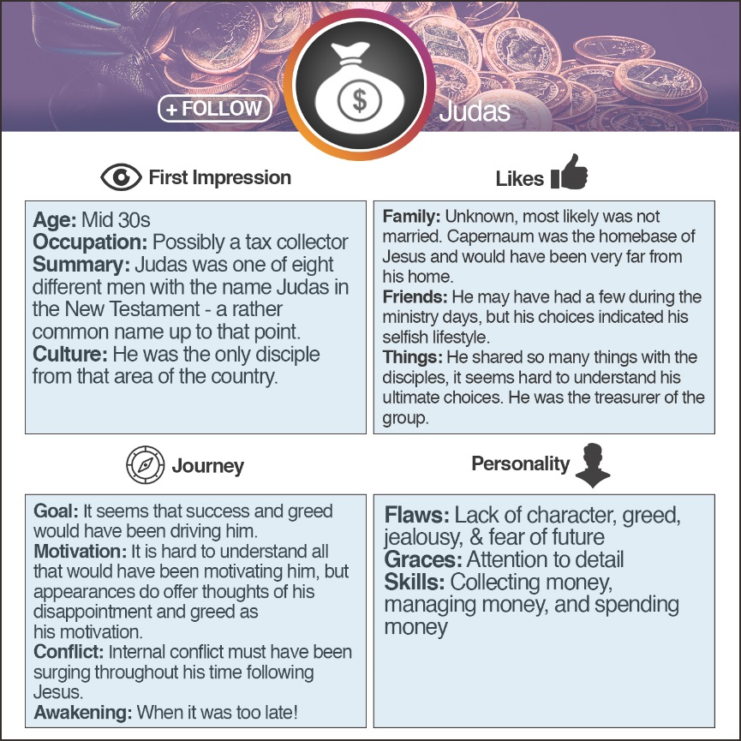
Judas = INTJ
Innovative, independent, strategic, logical, reserved, insightful. Driven by their own original ideas to achieve improvements
Myers-Briggs:
To increase energy, those who…
Turn to others are an E (extroversion) Turn inward are I (introversion)
Those who take in information in a…
Creative way are an N (intuition) Pragmatic way are S (sensing)
When making decisions, those who…
Seek harmony are an F (feeling) Seek objective truth are T (thinking)
Those who prefer to…
Get closer and act are a J (judging) Stay open and adapt are P (perceiving)

Here is how the progression of experiences happened for Judas…
- Judas was as one of the twelve. (Luke 6:12-16; Mark 3:13-19)
- Judas was as one of the twelve. (Matthew 10:4)
- Judas Jesus miracles and teaching.
(Mark 3:14)
- Judas was put in of the treasury. (John 12:6, 13:29)
- Judas begins to money. (John 12:6)
- When Mary the feet of Jesus, Judas speaks out as to the waste of money. (John 12:1-8)
- Judas sees the Pharisees and chief priests plotting to Jesus. (Matthew 26:3-5)
- Judas strikes a with them to betray Jesus. (Matthew 26:14-15)
- Judas to look for the opportune moment to betray Jesus. (Mark 14:11)
- Judas is with Jesus at the Last Supper in a place of
. (John 13:26)
- Jesus bread with Judas revealing that one would betray Him. (John 13:21-27)
- Judas the bread and is possessed by Satan. (John 13:27)
- Judas the soldiers to Jesus for the betrayal. (John 18:1-9)
- Judas his betrayal, returns the money, and then, in remorse, hangs himself. (Acts 1:15-19)

What did all this mean to Judas?
- He was privileged to be one of the twelve!
- He saw crowds flocking to Jesus!
- He witnessed Jesus’ own family thinking he was crazy! (Mark 3:21)
- He witnessed the potential power, influence, and wealth…even a fast-track to success!

- Somehow, Judas heard the messages but never listened…
“Don’t store up treasures here on earth, where moths eat them and rust destroys them, and where thieves break in and steal. Store your treasures in heaven, where moths and rust cannot destroy, and thieves do not break in and steal. Wherever your treasure is, there the desires of your heart will also be.”
“No one can serve two masters. For you will hate one and love the other; you will be devoted to one and despise the other. You cannot serve God and be enslaved to money.” Matthew 19-21, 24
- Judas missed the messages of “storing your treasures in heaven.”
- Judas missed the messages of “where your heart is your treasure will also be.”
- Judas missed the messages that you “can’t have two masters, God and money!”
- He missed the whole concept of the “love of money is the root of all evil.”

If you were friends with Judas, what takeaway would you gain from your friendship?
From Judas:
- Hearing a message does not mean you are listening. There is a conscious choice to take a message into your heart.
- We should always check our motives. Whenever they are in conflict with God’s goals, we need to re-align our goals.
- Judas’ heart was revealed by his words.
- Seeing is not believing.
- Our weakness could be our downfall when it is not guarded.
- Remorse for sin is evidenced by a change in behavior.

- Hanging with all the right people, going to the right places, and even doing the right things does not assure us of an eternity with Jesus. Only living by faith for Jesus brings us into a right relationship with Jesus.
From Jesus:
- Never, never, never give up on those you love!
- God believes in us and see us beyond who we are.
- Don’t harbor feelings against those who would seek to do evil to you, but love them unconditionally.
- It is never too late to make a difference in those in your world.
- Teaching truth does not mean it is learned.
- It is important to release those you love to make decisions on their own.
- There is a very hard realization that although you may invest significantly in others, they still may make disappointing decisions.
- Ultimately, we have to trust God with all things that are in our future…He has the best plan yet!

Summer sermon series:

August 29: Begins 40 Days of Prayer and Fasting

September 10, 2017 A new 8-week series called:
“Life Verse – A Close Encounter,
When God Gives Direction for Our Lives.” (Each of your pastors will talk about how the Word of God has guided their lives or how God has given them a passage for life.)

ISTJ –Responsible, sincere, analytical, reserved, realistic, systematic. Hardworking and trustworthy with sound practical judgment. | ISFJ – Warm considerate, gentle, responsible, pragmatic, and thorough. Devoted caretakers who enjoy being helpful to others.
INFJ – Idealistic, organized, insightful, dependable, compassionate and gentle. Seek harmony and cooperation, enjoy intellectual stimulation. | INTJ – Innovative, independent, strategic, logical, reserved, insightful. Driven by their own original ideas to achieve improvements.
ISTP – Action-oriented, logical, analytical, spontaneous, reserved, independent. Enjoy adventure skilled at understanding how mechanical things work. | ISFP – Gentle, sensitive, nurturing, helpful, flexible, realistic. Seek to create a personal environment that is both beautiful and practical.
INFP – Sensitive, creative, idealistic, perceptive, caring, loyal. Value inner harmony and personal growth, focus on dreams and possibilities. | INTP – Intellectual, logical, precise, reserved, flexible, imaginative. Original thinkers who enjoy speculation and creative problem solving.
ESTP – Outgoing, realistic, action-oriented, curious, versatile, spontaneous. Pragmatic problem solvers and skillful negotiators. | ESFP – Playful, enthusiastic, friendly, spontaneous, tactful, flexible. Have strong common sense; enjoy helping people in tangible ways.
ENFP – Enthusiastic, creative spontaneous, optimistic, supportive, playful. Value inspiration; enjoy starting new projects, see potential in others. | ENTP – Inventive, enthusiastic, strategic, enterprising, inquisitive, versatile. Enjoy new ideas and challenges, value inspiration.
ESTJ – Efficient, outgoing, analytical, systematic, dependable, realistic. Like to run the show and get things done in an orderly fashion. | ESFJ – Friendly, outgoing, reliable, conscientious, organized, practical. Seek to be helpful and please others, enjoy being active and productive.
ENFJ – Caring, enthusiastic, idealistic, organized, diplomatic, responsible. Skilled communicators who value connection with people. | ENTJ – Strategic, logical, efficient, outgoing, ambitious, independent. Effective organizers of people and long- range planners.

