August 20, 2017
“Jesus and a Few Friends”
“Now you are my friends, since I have told you
everything the Father told me.” John 15:15b
“Lunch with a Few More Friends: You Feed Them
– The Disciples Dilemma”
“But Jesus said, ‘That isn’t necessary—you feed them.’”
Matthew 14:16

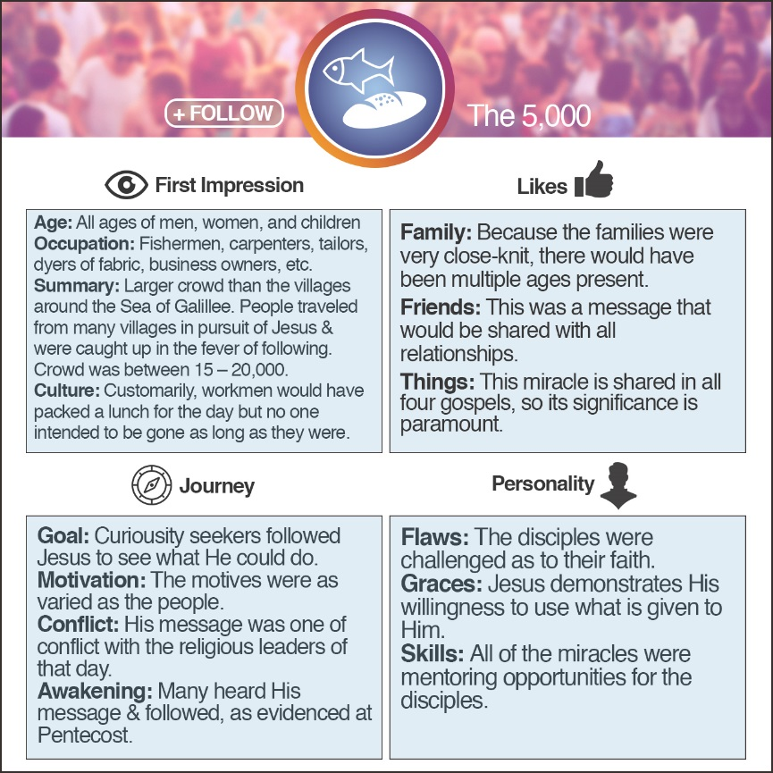
Philip = ISFJ
ISFJ: Warm considerate, gentle, responsible, pragmatic, and thorough. Devoted caretakers who enjoy being helpful to others.
Myers-Briggs:
To increase energy, those who…
Turn to others are an E (extroversion) Turn inward are I (introversion)
Those who take in information in a…
Creative way are an N (intuition) Pragmatic way are S (sensing)
When making decisions, those who…
Seek harmony are an F (feeling) Seek objective truth are T (thinking)
Those who prefer to…
Get closer and act are a J (judging) Stay open and adapt are P (perceiving)

Jesus …
- Jesus had just the news about John the Baptist.
“As soon as Jesus heard the news, he left in a boat…” Matthew 14:13a
- Jesus had just His disciples together to hear their news of their ministry experiences.
“The apostles returned to Jesus from their ministry tour and told him all they had done and taught.” Mark 6:30
- Jesus had he needed time alone.
“…he left in a boat to a remote area to be alone…” Matthew 14:13b
- Jesus had time alone, but the needs of those following stirred His heart!
“But the crowds heard where he was headed and followed on foot from many towns. Jesus saw the huge crowd as he stepped from the boat, and he had compassion on them and healed their sick.” Matthew 14:13c-14

Here’s how the story …
Matthew 14; Mark 6; Luke 9; John 6
- The disciples came with the of the crowd.
“Late in the afternoon his disciples came to him and said, ‘This is a remote place, and it’s already getting late. Send the crowds away so they can go to the nearby farms and villages and buy something to eat.’” Mark 6:35-36
- The disciples had not either.
“He said this because there were so many people coming and going that Jesus and his apostles didn’t even have time to eat.”
Mark 6:31b
- Jesus responded by the responsibility back on them.
“But Jesus said, ‘You feed them.’” Mark 6:37a
- The disciples were !
“‘With what?’ they asked. ‘We’d have to work for months to earn enough money to buy food for all these people!’” Mark 6:37b
- Jesus asked what they .
“‘How much bread do you have?’ he asked. ‘Go and find out.’” Mark 6:38a

- There was one young boy’s .
“Then Andrew, Simon Peter’s brother, spoke up. ‘There’s a young boy here with five barley loaves and two fish. But what good is that with this huge crowd?’” John 6:8-9
- Jesus instructed the to direct the crowds (between 200-400 groups).
““Tell everyone to sit down,” Jesus said. So they all sat down on the grassy slopes. (The men alone numbered about 5,000.)” John 6:10
- Jesus the loaves and distributed them!
“Then Jesus took the loaves, gave thanks to God, and distributed them to the people. Afterward he did the same with the fish. And they all ate as much as they wanted.” John 6:11
- The twelve disciples gathered baskets of leftovers.
“After everyone was full, Jesus told his disciples, ‘Now gather the leftovers, so that nothing is wasted.’ So they picked up the pieces and filled twelve baskets with scraps left by the people who had eaten from the five barley loaves.” John 6:12-13

If you were friends with the disciples and a face in the crowd, what takeaway would you gain from your friendship?
From the disciples:
- We always have the answer to our needs with us, wherever we go!
- Don’t forget the miracles of the past!
- All that Jesus wants is what we have, not what we don’t have!
- If Jesus did it once, He can do it again! (5,000; 4,000)
- Remember, God always has a plan and is never caught off-guard.
- Our original destination may not be where we end up…and that’s ok!
From Jesus:
- Sometimes our own needs have to be secondary to the needs around us.
- When God looks at a crowd, He always sees individual needs with compassion!
- Jesus will take your little, multiply it, and use it to minister to the lives of many!
- God never wastes anything that is surrendered to Him.
- When God does a miracle, there is more than enough!
- Remember…the miracle didn’t happen until there was a surrender of what they did have to Jesus and a letting go of fish and loaves to the crowd. Trusting Jesus for a miracle means we surrender what we have…let go of our expectations…and allow Him to bring the miracle as He sees!

Summer sermon series:

August 27, 2017
Dinner With a Friend:
Life Change For All The Right Reasons - Zacchaeus!
September 3, 2017
When A Friendship Goes Bad:
Friends Aren’t Always Forever - Judas!

ISTJ –Responsible, sincere, analytical, reserved, realistic, systematic. Hardworking and trustworthy with sound practical judgment. | ISFJ – Warm considerate, gentle, responsible, pragmatic, and thorough. Devoted caretakers who enjoy being helpful to others.
INFJ – Idealistic, organized, insightful, dependable, compassionate and gentle. Seek harmony and cooperation, enjoy intellectual stimulation. | INTJ – Innovative, independent, strategic, logical, reserved, insightful. Driven by their own original ideas to achieve improvements.
ISTP – Action-oriented, logical, analytical, spontaneous, reserved, independent. Enjoy adventure skilled at understanding how mechanical things work. | ISFP – Gentle, sensitive, nurturing, helpful, flexible, realistic. Seek to create a personal environment that is both beautiful and practical.
INFP – Sensitive, creative, idealistic, perceptive, caring, loyal. Value inner harmony and personal growth, focus on dreams and possibilities. | INTP – Intellectual, logical, precise, reserved, flexible, imaginative. Original thinkers who enjoy speculation and creative problem solving.
ESTP – Outgoing, realistic, action-oriented, curious, versatile, spontaneous. Pragmatic problem solvers and skillful negotiators. | ESFP – Playful, enthusiastic, friendly, spontaneous, tactful, flexible. Have strong common sense; enjoy helping people in tangible ways.
ENFP – Enthusiastic, creative spontaneous, optimistic, supportive, playful. Value inspiration; enjoy starting new projects, see potential in others. | ENTP – Inventive, enthusiastic, strategic, enterprising, inquisitive, versatile. Enjoy new ideas and challenges, value inspiration.
ESTJ – Efficient, outgoing, analytical, systematic, dependable, realistic. Like to run the show and get things done in an orderly fashion. | ESFJ – Friendly, outgoing, reliable, conscientious, organized, practical. Seek to be helpful and please others, enjoy being active and productive.
ENFJ – Caring, enthusiastic, idealistic, organized, diplomatic, responsible. Skilled communicators who value connection with people. | ENTJ – Strategic, logical, efficient, outgoing, ambitious, independent. Effective organizers of people and long- range planners.

