August 13, 2017
“Jesus and a Few Friends”
“Now you are my friends, since I have told you
everything the Father told me.” John 15:15b
“Close Friends: Sharing Life Together
– Peter, James, and John!”
“Here are the names of the twelve apostles: first, Simon (also called Peter), then Andrew (Peter’s brother), James (son of Zebedee), John (James’s brother),” Matthew 10:2
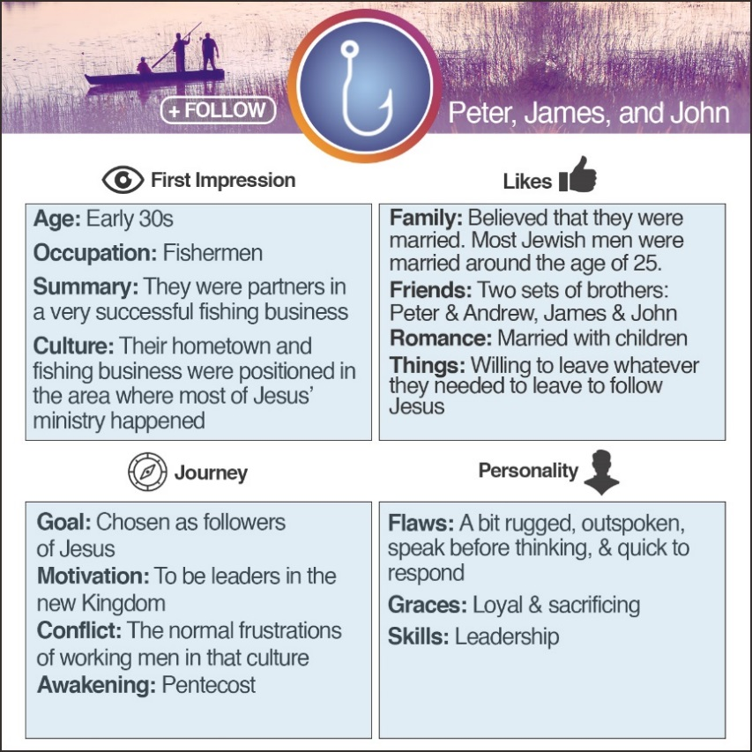
Peter = ENFP James = ESTP John = ISTP
ENFP – Enthusiastic, creative, spontaneous, optimistic, supportive, playful, value inspiration, enjoy starting new projects, and see potential in others.
ESTP – Outgoing, realistic, action-oriented, curious, versatile, spontaneous, pragmatic, problem solvers, and skillful negotiators.
ISTP – Action-oriented, logical, analytical, spontaneous, reserved, independent, enjoy adventure, and skilled at understanding how mechanical things work.
Myers-Briggs:
To increase energy, those who…
Turn to others are an E (extroversion) Turn inward are I (introversion)
Those who take in information in a…
Creative way are an N (intuition) Pragmatic way are S (sensing)
When making decisions, those who…
Seek harmony are an F (feeling) Seek objective truth are T (thinking)
Those who prefer to…
Get closer and act are a J (judging) Stay open and adapt are P (perceiving)

Peter, James, and John were…
- All . They were partners in a prosperous fishing business. They owned their own nets, boats, and had multiple employees working for them.
“He called them at once, and they also followed him, leaving their father, Zebedee, in the boat with the hired men.”
Mark 1:20
- . Most likely, the brothers spoke Hebrew, Greek (the language of the elite and educated), and Aramaic (with a Galilean accent).
“A little later some of the other bystanders came over to Peter and said, ‘You must be one of them; we can tell by your Galilean accent.’" Matthew 26:73
- Based in . Peter’s house and their fishing business became Capernaum. Capernaum became the “hometown” for Jesus’ earthly ministry.
“He went first to Nazareth, then left there and moved to Capernaum, beside the Sea of Galilee, in the region of Zebulun and Naphtali.” Matthew 4:13
- Living in the most inland sea area. The Sea of Galilee became significant as the beginning of Jesus’ ministry took place there as well.
- Calling of Peter, Andrew, James, and John
- Calming of the storm
- Feeding of the 5,000
- Walking on the sea
- Feeding of the 4,000
- Jesus and the many boats
- Appearance of resurrected Jesus
“One day as Jesus was walking along shore of the Sea of Galilee, he saw two brothers—Simon, also called Peter, and Andrew—throwing a net into the water, for they fished for a living.” Matthew 4:18

The brothers and disciples…
- Two sets of became the first disciples of Jesus to become apostles. Jesus picked ordinary men to become his first followers. Andrew and John were disciples of John the Baptist.
“‘Come and see,’ he said. It was about four o’clock in the afternoon when they went with him to the place where he was staying, and they remained with him the rest of the day.”
John 1:39
- The four were the top of disciples who were called early and given the most mentoring time.
“Here are the names of the twelve apostles: first, Simon (also called Peter), then Andrew (Peter’s brother), James (son of Zebedee), John (James’s brother),” Matthew 10:2
- Peter, James, and John witnessed the
______________ of the child who had been raised from the dead.
“Then Jesus stopped the crowd and wouldn’t let anyone go with him except Peter, James, and John (the brother of James).”
Mark 5:37
- Peter, James, and John witnessed the
.
“Six days later Jesus took Peter and the two brothers, James, and John, and led them up a high mountain to be alone.”
Matthew 17:1
- The two sets of brothers listened to Jesus speaking about His .
“Later, Jesus sat on the Mount of Olives across the valley from the Temple. Peter, James, John, and Andrew came to him privately and asked him,” Mark 13:3
- Peter, James, and John were with Jesus in the
as he prayed.
“He took Peter and Zebedee’s two sons, James and John, and he became anguished and distressed.” Matthew 26:37
- Peter, James, and John were with the disciples in the Room.
“When they arrived, they went to the upstairs room of the house where they were staying. Here are the names of those who were present: Peter, John, James, Andrew, Philip, Thomas, Bartholomew, Matthew, James (son of Alphaeus), Simon (the zealot), and Judas (son of James).” Acts 1:13
- Peter, James, and John became the of the early church.
“In fact, James, Peter, and John, who were known as pillars of the church, recognized the gift God had given me, and they accepted Barnabas and me as their co-workers. They encouraged us to keep preaching to the Gentiles, while they continued their work with the Jews.” Galatians 2:9

If you were friends with Peter, James, and John, what takeaway would you gain from your friendship?
From Peter, James, and John:
- The name you begin with is not necessarily the name you end with…Simon/Thunder!
- What if Andrew hadn’t been obedient? The primary leader of the church was brought to Jesus by Andrew.
- To be great in God’s Kingdom requires more time with Jesus.
- Don’t let fear keep you from fully following Christ!
- Ordinary can become extraordinary when God is behind you!
- Don’t allow a lack of understanding to keep you from following. Continue to trust and allow God to lead, even when things do not seem to be what you anticipated.
From Jesus:
- All of us need close friends to share time.
- Even your best friends may not understand you.
- God looks at who you can be, not at who you are!
- God will use the everyday, ordinary experiences of our lives to prepare us for greater things.
- God will teach you greater things from your failures than your successes.
- You cannot always depend on those you love to always be there…but God can always be depended upon!

Summer sermon series:

August 20, 2017
Lunch with a Few More Friends:
You Feed Them – The Disciples’ Dilemma!
August 27, 2017
Dinner with a Friend:
Life Change For All The Right Reasons - Zacchaeus!
September 3, 2017
When A Friendship Goes Bad:
Friends Aren’t Always Forever - Judas!

ISTJ –Responsible, sincere, analytical, reserved, realistic, systematic. Hardworking and trustworthy with sound practical judgment. | ISFJ – Warm considerate, gentle, responsible, pragmatic, and thorough. Devoted caretakers who enjoy being helpful to others.
INFJ – Idealistic, organized, insightful, dependable, compassionate and gentle. Seek harmony and cooperation, enjoy intellectual stimulation. | INTJ – Innovative, independent, strategic, logical, reserved, insightful. Driven by their own original ideas to achieve improvements.
ISTP – Action-oriented, logical, analytical, spontaneous, reserved, independent. Enjoy adventure skilled at understanding how mechanical things work. | ISFP – Gentle, sensitive, nurturing, helpful, flexible, realistic. Seek to create a personal environment that is both beautiful and practical.
INFP – Sensitive, creative, idealistic, perceptive, caring, loyal. Value inner harmony and personal growth, focus on dreams and possibilities. | INTP – Intellectual, logical, precise, reserved, flexible, imaginative. Original thinkers who enjoy speculation and creative problem solving.
ESTP – Outgoing, realistic, action-oriented, curious, versatile, spontaneous. Pragmatic problem solvers and skillful negotiators. | ESFP – Playful, enthusiastic, friendly, spontaneous, tactful, flexible. Have strong common sense; enjoy helping people in tangible ways.
ENFP – Enthusiastic, creative spontaneous, optimistic, supportive, playful. Value inspiration; enjoy starting new projects, see potential in others. | ENTP – Inventive, enthusiastic, strategic, enterprising, inquisitive, versatile. Enjoy new ideas and challenges, value inspiration.
ESTJ – Efficient, outgoing, analytical, systematic, dependable, realistic. Like to run the show and get things done in an orderly fashion. | ESFJ – Friendly, outgoing, reliable, conscientious, organized, practical. Seek to be helpful and please others, enjoy being active and productive.
ENFJ – Caring, enthusiastic, idealistic, organized, diplomatic, responsible. Skilled communicators who value connection with people. | ENTJ – Strategic, logical, efficient, outgoing, ambitious, independent. Effective organizers of people and long- range planners.

