July 16, 2017
“Jesus and a Few Friends”
“Now you are my friends, since I have told you
everything the Father told me.” John 15:15b

“Losing a Friend: Dealing with Loss – Lazarus!”
“Jesus told her, ‘I am the resurrection and the life. Anyone who believes in me will live, even after dying’” John 11:25

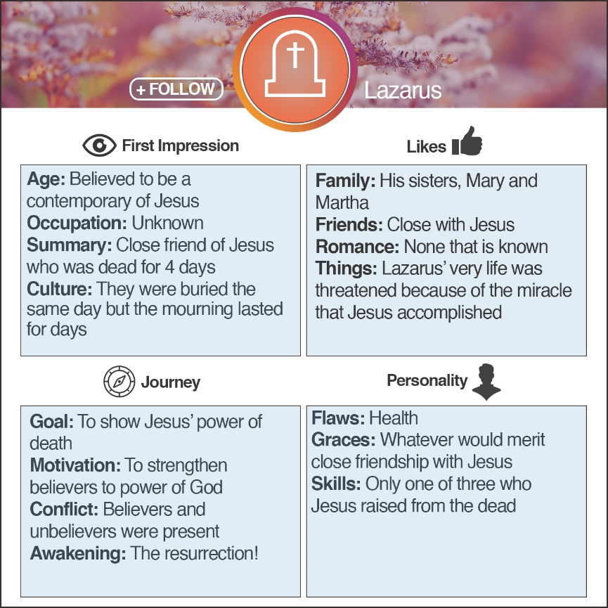
Lazarus = INTP
Myers-Briggs:
To increase energy, those who…
Turn to others are an E (extroversion) Turn inward are I (introversion)
Those who take in information in a…
Creative way are an N (intuition) Pragmatic way are S (sensing)
When making decisions, those who…
Seek harmony are an F (feeling) Seek objective truth are T (thinking)
Those who prefer to…
Get closer and act are a J (judging) Stay open and adapt are P (perceiving)
http://www.humanmetrics.com
https://www.16personalities.com

Lazarus was a friend of Jesus…

Referred to in John 11:1-46; John 12:1-11
- Jesus received the of Lazarus’ illness.
“So the two sisters sent a message to Jesus telling him, ‘Lord, your dear friend is very sick.’” John 11:3
- Jesus His trip two days.
“So although Jesus loved Martha, Mary, and Lazarus, he stayed where he was for the next two days.” Vs 5
- Jesus puts His life in by caring for His friends.
“But his disciples objected. ‘Rabbi,’ they said, ‘only a few days ago the people in Judea were trying to stone you. Are you going there again?’” Vs 8
- Jesus met Martha , outside of the village.
“When Martha got word that Jesus was coming, she went to meet him. But Mary stayed in the house.” Vs 20
- Jesus met Mary and Jesus was deeply
.
“Then she returned to Mary. She called Mary aside from the mourners and told her, ‘The Teacher is here and wants to see you.’” Vs 28
“When Jesus saw her weeping and saw the other people wailing with her, a deep anger welled up within him, and he was deeply troubled.” Vs 33
“Then Jesus wept.” Vs 35
“Jesus was still angry as he arrived at the tomb, a cave with a stone rolled across its entrance.” Vs 38
- Jesus called Lazarus .
“Then Jesus shouted, ‘Lazarus, come out!’” Vs 43
- Jesus told them to him and let him go!
“And the dead man came out, his hands and feet bound in graveclothes, his face wrapped in a headcloth. Jesus told them, ‘Unwrap him and let him go!’” Vs 44

If you were friends with Lazarus, what takeaway would you gain from your friendship?
- From Lazarus – Sickness can come to all of us, even when we are following close to Jesus!
- From Martha – God’s timing is not always our timing, even when things look bleak!
- From Thomas – There are times when being a disciple of Jesus puts us in jeopardy. Follow anyway!
- From the disciples, Mary, and Martha – Sometimes we forget the powerful work of God in the past and just need to be reminded.
- From the crowd – Life is not always interpreted appropriately.
- From Jesus – Faith will always empower you to see the glory of God.
- From Jesus – there are times when we need to use words to be a witness and bring glory to God.
- From Jesus – Jesus has power over death and we can trust Him with that!
- From Jesus – Although God could work without us, He chooses to work with us and through us! (“Roll the stone,” “Unwrap him”)
- From Jesus – Although Jesus worked the miracle, there was still a next step that needed to be taken before freedom happened!

Summer sermon series:

July 23, 2017
Trusting A Close Friend: The Many Sides of Peter!
July 30, 2017
Friend in the Military: Defending and Believing –The Centurion!
August 6, 2017
Taking Advantage of Friendship:
Pushing a Little Too Hard – Mrs. Zebedee!

ISTJ –Responsible, sincere, analytical, reserved, realistic, systematic. Hardworking and trustworthy with sound practical judgment. | ISFJ – Warm considerate, gentle, responsible, pragmatic, and thorough. Devoted caretakers who enjoy being helpful to others.
INFJ – Idealistic, organized, insightful, dependable, compassionate and gentle. Seek harmony and cooperation, enjoy intellectual stimulation. | INTJ – Innovative, independent, strategic, logical, reserved, insightful. Driven by their own original ideas to achieve improvements.
ISTP – Action-oriented, logical, analytical, spontaneous, reserved, independent. Enjoy adventure skilled at understanding how mechanical things work. | ISFP – Gentle, sensitive, nurturing, helpful, flexible, realistic. Seek to create a personal environment that is both beautiful and practical.
INFP – Sensitive, creative, idealistic, perceptive, caring, loyal. Value inner harmony and personal growth, focus on dreams and possibilities. | INTP – Intellectual, logical, precise, reserved, flexible, imaginative. Original thinkers who enjoy speculation and creative problem solving.
ESTP – Outgoing, realistic, action-oriented, curious, versatile, spontaneous. Pragmatic problem solvers and skillful negotiators. | ESFP – Playful, enthusiastic, friendly, spontaneous, tactful, flexible. Have strong common sense; enjoy helping people in tangible ways.
ENFP – Enthusiastic, creative spontaneous, optimistic, supportive, playful. Value inspiration; enjoy starting new projects, see potential in others. | ENTP – Inventive, enthusiastic, strategic, enterprising, inquisitive, versatile. Enjoy new ideas and challenges, value inspiration.
ESTJ – Efficient, outgoing, analytical, systematic, dependable, realistic. Like to run the show and get things done in an orderly fashion. | ESFJ – Friendly, outgoing, reliable, conscientious, organized, practical. Seek to be helpful and please others, enjoy being active and productive.
ENFJ – Caring, enthusiastic, idealistic, organized, diplomatic, responsible. Skilled communicators who value connection with people. | ENTJ – Strategic, logical, efficient, outgoing, ambitious, independent. Effective organizers of people and long- range planners.

