July 2, 2017
“Jesus and a Few Friends”
“Now you are my friends, since I have told you
everything the Father told me.” John 15:15b

“Wanting the Best for Your Friends:
Greater and Lesser – John the Baptist!”
“He must become greater and greater, and I must become less and less.” John 3:30

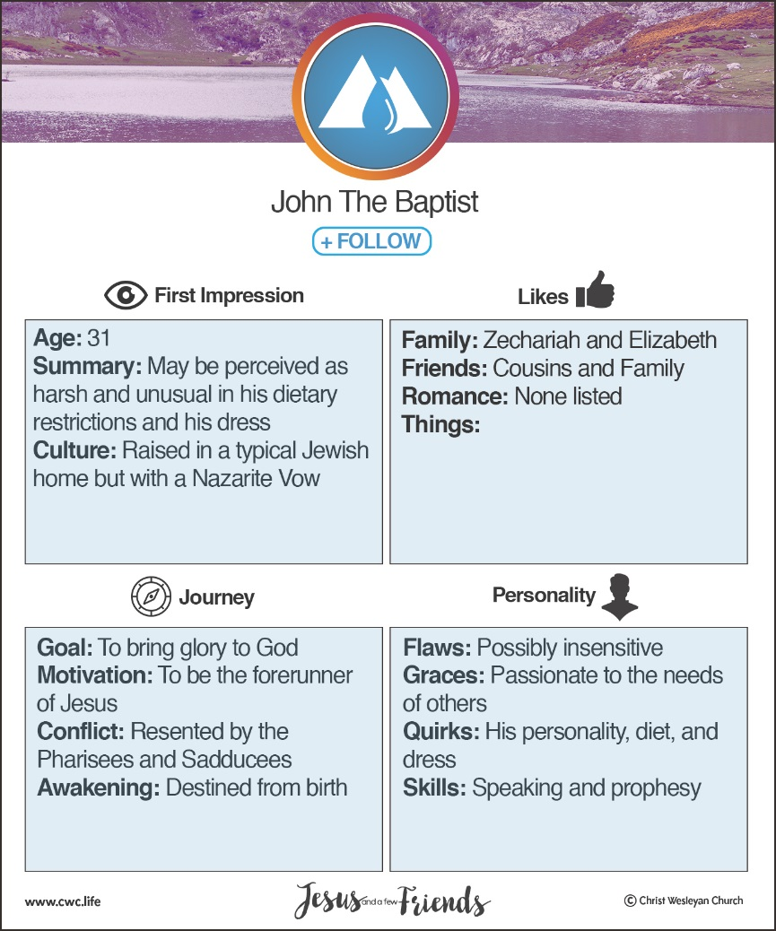

John the Baptist = ENFJ
Myers-Briggs:
To increase energy, those who…
Turn to others are an E (extroversion) Turn inward are I (introversion)
Those who take in information in a…
Creative way are an N (intuition) Pragmatic way are S (sensing)
When making decisions, those who…
Seek harmony are an F (feeling) Seek objective truth are T (thinking)
Those who prefer to…
Get closer and act are a J (judging) Stay open and adapt are P (perceiving)
http://www.humanmetrics.com

The of John’s life…

“‘What will this child turn out to be?’ For the hand of the Lord was surely upon him in a special way.” Luke 1:66b
- John his life with knowing his purpose.

“And you, my little son, will be called the prophet of the Most High, because you will prepare the way for the Lord.” Luke 1:76
- John even knew to use his purpose.
“You will tell his people how to find salvation through forgiveness of their sins.” Luke 1:77
- John knew to share with his hearers.
“to give light to those who sit in darkness and in the shadow of death, and to guide us to the path of peace.” Luke 1:79
- John knew his would always be to support a great mission.
“John grew up and became strong in spirit. And he lived in the wilderness until he began his public ministry to Israel.” Luke 1:80
- Because John knew his life purpose was to be a support, he dealt with his feelings of being displaced. It was all about …
and not him!
“The following day John was again standing with two of his disciples. As Jesus walked by, John looked at him and declared, ‘Look! There is the Lamb of God!’ When John’s two disciples heard this, they followed Jesus.” John 1:35-37
“Andrew, Simon Peter’s brother, was one of these men who heard what John said and then followed Jesus.” John 1:40
“So John’s disciples came to him and said, ‘Rabbi, the man you met on the other side of the Jordan River, the one you identified as the Messiah, is also baptizing people. And everybody is going to him instead of coming to us.’
John replied, ‘No one can receive anything unless God gives it from heaven. You yourselves know how plainly I told you, “I am not the Messiah. I am only here to prepare the way for him.” It is the bridegroom who marries the bride, and the bridegroom’s friend is simply glad to stand with him and hear his vows. Therefore, I am filled with joy at his success. He must become greater and greater, and I must become less and less.’” John 3:26-30

- The of John’s message…
“John grew up and became strong in spirit.” Luke 1:80a
- Repentance is the groundwork for true .
“Repent of your sins and turn to God, for the Kingdom of Heaven is near.” Mathew 3:2
- Baptism is the testimony of a life.
“…preaching that people should be baptized to show that they had repented of their sins and turned to God to be forgiven.” Luke 3:3b
- Forgiveness was the to a relationship with God!
“This messenger was John the Baptist. He was in the wilderness and preached that people should be baptized to show that they had repented of their sins and turned to God to be forgiven.” Mark 1:4
- Our Christian life must produce that looks like Jesus! Your life should be evidence of your faith!
“Prove by the way you live that you have repented of your sins and turned to God.” Luke 3:8a
- Evidence of a changed life is found in our generosity, our , and our integrity!
“The crowds asked, ‘What should we do?’ John replied, ‘If you have two shirts, give one to the poor. If you have food, share it with those who are hungry.’ Even corrupt tax collectors came to be baptized and asked, ‘Teacher, what should we do?’ He replied, ‘Collect no more taxes than the government requires.’ ‘What should we do?’ asked some soldiers.
John replied, ‘Don’t extort money or make false accusations. And be content with your pay.’” Luke 3:10-14

- The of John’s commitment…
“for Herod respected John; and knowing that he was a good and holy man, he protected him. Herod was greatly disturbed whenever he talked with John, but even so, he liked to listen to him.” Mark 6:20
- John’s life caused Herod to John and thus, to protect him.
- John’s preceded him. Herod knew him to be a righteous and holy man.
- John was hated because he stood for .
- John’s life was taken for his .

If you were friends with John, what take away would you gain from your friendship?
- Find a purpose that is worth dying!
- Do not allow negative feelings to steal your joy and your heart for following Jesus!
- Forgiveness is a necessary process to find peace with God!
- Life change is evidence to the world and will then become a testimony of hope and healing for all!
- Remember to be bold in your faith, even if it costs you! Standing for Jesus will always come with a price!

Summer sermon series:
July 9, 2017
Friends with Same Genes but Different: Getting along in spite of our differences – Mary and Martha! Luke 10:38-42
July 16, 2017
Losing a Friend: Dealing with loss – Lazarus!

July 23, 2017
Trusting A Close Friend: The many sides of Peter!

July 30, 2017
Friend in the Military: Defending and Believing – the centurion!
ISTJ –Responsible, sincere, analytical, reserved, realistic, systematic. Hardworking and trustworthy with sound practical judgment. | ISFJ – Warm considerate, gentle, responsible, pragmatic, and thorough. Devoted caretakers who enjoy being helpful to others.
INFJ – Idealistic, organized, insightful, dependable, compassionate and gentle. Seek harmony and cooperation, enjoy intellectual stimulation. | INTJ – Innovative, independent, strategic, logical, reserved, insightful. Driven by their own original ideas to achieve improvements.
ISTP – Action-oriented, logical, analytical, spontaneous, reserved, independent. Enjoy adventure skilled at understanding how mechanical things work. | ISFP – Gentle, sensitive, nurturing, helpful, flexible, realistic. Seek to create a personal environment that is both beautiful and practical.
INFP – Sensitive, creative, idealistic, perceptive, caring, loyal. Value inner harmony and personal growth, focus on dreams and possibilities. | INTP – Intellectual, logical, precise, reserved, flexible, imaginative. Original thinkers who enjoy speculation and creative problem solving.
ESTP – Outgoing, realistic, action-oriented, curious, versatile, spontaneous. Pragmatic problem solvers and skillful negotiators. | ESFP – Playful, enthusiastic, friendly, spontaneous, tactful, flexible. Have strong common sense; enjoy helping people in tangible ways.
ENFP – Enthusiastic, creative spontaneous, optimistic, supportive, playful. Value inspiration; enjoy starting new projects, see potential in others. | ENTP – Inventive, enthusiastic, strategic, enterprising, inquisitive, versatile. Enjoy new ideas and challenges, value inspiration.
ESTJ – Efficient, outgoing, analytical, systematic, dependable, realistic. Like to run the show and get things done in an orderly fashion. | ESFJ – Friendly, outgoing, reliable, conscientious, organized, practical. Seek to be helpful and please others, enjoy being active and productive.
ENFJ – Caring, enthusiastic, idealistic, organized, diplomatic, responsible. Skilled communicators who value connection with people. | ENTJ – Strategic, logical, efficient, outgoing, ambitious, independent. Effective organizers of people and long- range planners.

