March 13, 2016

The Pursuit: His Unrelenting Plan to Save Us
A series on Jesus’ last week
The Gospel of John: Chapters 13-21

“He Suffered: Standing for Truth” John 18-19:16
“Jesus responded, ‘You say I am a king. Actually I was born and came into the world to testify to the truth. All who love the truth recognize that what I say is true.’” John 18:37
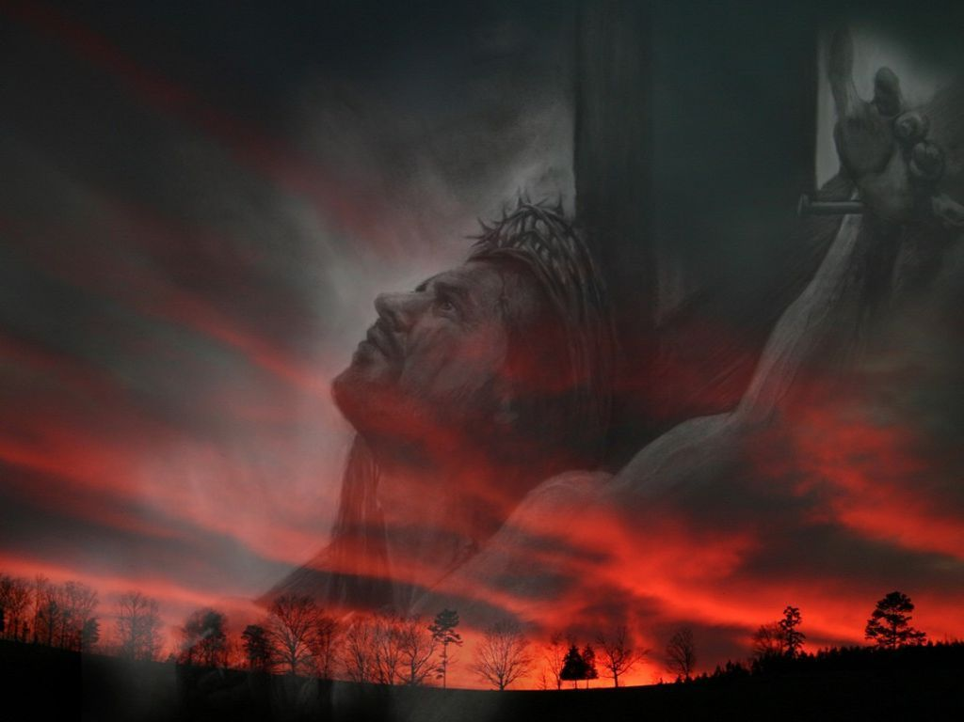

Standing for the Truth: …
“I am he,” Vs 18:5b
- Peter’s first attempt to Jesus ended with a sword, a healing, a reminder, and confusion.
“Put your sword back into its sheath. Shall I not drink from the cup of suffering the Father has given me?” Vs 18:11
- Peter’s second attempt to for the Truth failed. Situationally, it was awkward; it was easy to deny the Truth to the woman watching the gate.
“You’re not one of that man’s disciples, are you?” Vs 18:17
- Peter’s third attempt to stand for the Truth failed. Once again, situationally, Peter was in a position of being cold and Peter stood with those around the fire who were on the side of the Truth.
“Because it was cold, the household servants and the guards had made a charcoal fire. They stood around it, warming themselves, and Peter stood with them, warming himself…Meanwhile, as Simon Peter was standing by the fire warming himself, they asked him again, ‘You’re not one of his disciples, are you?’” Vs 18:18, 25
- Peter’s fourth attempt to stand for the Truth failed. Situationally, it became easier to the Truth once the lie had been spoken. This time, one of the relatives of the injured slave from the Garden brought the accusation. Now a distance from Jesus…he realized his failure.
“But one of the household slaves of the high priest, a relative of the man whose ear Peter had cut off, asked, ‘Didn’t I see you out there in the olive grove with Jesus?’” Vs 18:26

- Standing for truth: …
- Pilate Jesus about truth.
“Are you the king of the Jews?” Vs 18:33
- Once again, questioned about truth.
“What is truth?” Vs 18:38a
- Pilate tried to truth and made Jesus suffer for the accusations. He sought to get around the truth and tried to pass it back to the Jewish leaders.
“‘Take him yourselves and crucify him,’ Pilate said. ‘I find him not guilty.’” Vs 19:6b
- Although Pilate was , he didn’t want to face truth, but rather chose to pass his guilt. Pilate lacked understanding as to his own power. By avoiding truth, Pilate never understood the power of Jesus and caved into the political pressure.
“Then Pilate tried to release him, but the Jewish leaders shouted, ‘If you release this man, you are no “friend of Caesar.” Anyone who declares himself a king is a rebel against Caesar.’” Vs 19:20

- Standing for the Truth: …
- Before the high priest, Jesus stood for the Truth and was by a Temple guard. The Truth cost Him.
“Everyone knows what I teach. I have preached regularly in the synagogues and the Temple, where the people gather. I have not spoken in secret.” Vs 18:20
- Before Pilate, Jesus stood for the Truth and was beaten, given a crown of , and a purple robe. The Truth cost Him.
“My Kingdom is not an earthly kingdom. If it were, my followers
would fight to keep me from being handed over to the Jewish
leaders. But my Kingdom is not of this world…You say I am a king.
Actually, I was born and came into the world to testify to the truth.
All who love the truth recognize that what I say is true.” Vs 18:36-37
- Jesus stood before the and they cried, “Crucify him! Crucify him!” Once again, he stood silently for the Truth and the Truth cost Him.
“Then Jesus came out wearing the crown of thorns and the purple
robe. And Pilate said, ‘Look, here is the man!’” Vs 19:5
- Jesus spoke the Truth because God ultimately has
over all things.
“You would have no power over me at all unless it were given to you from above. So the one who handed me over to you has the greater sin.” Vs 19:11

- Standing for the Truth: …
- Are you willing to stand for the Truth even though circumstances may be awkward?
- Are you willing to stand for the Truth even though your friends are against you?
- Are you willing to stand for the Truth even though the crowd is against you?
- Are you willing to stand for the Truth even when it will cost you?
- There is no power greater than God and His Truth is the ultimate truth for us to obey…so stand for the Truth courageously, unashamedly, and unreservedly! He is Truth! He stood for you…so stand for Him!
“For I am not ashamed of the gospel, because it is the power of God that brings salvation to everyone who believes…” Romans 1:16a

“Unless we stand for something, we shall fall for anything” –Peter Marshall

March 20, 2016

“He Died: Completing the Mission”
John 19:16-42
“Jesus knew that his mission was now finished…he said, ‘It is finished!’ Then he bowed his head and released his spirit.” John 19:28a, 30b

