February 28, 2016

The Pursuit: His Unrelenting Plan to Save Us
A series on Jesus’ last week
The Gospel of John: Chapters 13-21

“He Readied: Facing the Future” John 14-16
“…I am going there to prepare a place for you? And if I go and prepare a place for you, I will come back and take you to be with me that you also may be where I am.” John 14:2b-3

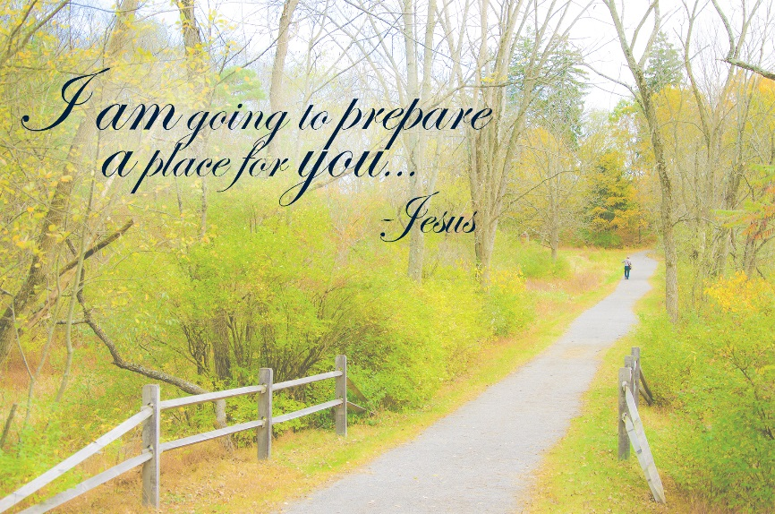

What does my future look like?
“Don’t let this throw you. You trust God, don’t you? Trust me. There is plenty of room for you in my Father’s home. If that weren’t so, would I have told you that I’m on my way to get a room ready for you? And if I’m on my way to get your room ready, I’ll come back and get you so you can live where I live.” The Message Vs 14:1
- Jesus has got this! He is getting things ready. He’s got this!
“Don’t let your hearts be troubled. Trust in God, and trust also in me.” Vs 14:1
- Jesus wants to be trusted.
“Trust in God, and trust also in me.” Vs 14:1b
- Jesus has provided a Friend who will always be with you.
“If you love me, show it by doing what I’ve told you. I will talk to the Father, and he’ll provide you another Friend so that you will always have someone with you. This Friend is the Spirit of Truth.” The Message Vs 14:15,16
- Jesus is giving us peace, no matter what we face.
“I’m leaving you well and whole. That’s my parting gift to you. Peace. I don’t leave you the way you’re used to being left—feeling abandoned, bereft. So don’t be upset. Don’t be distraught.” The Message
“Peace I leave with you; my peace I give you. I do not give to you as the world gives. Do not let your hearts be troubled and do not be afraid.” Vs 14:27

- What if the future isn’t what I planned?
- Jesus has got this! He is getting things ready. He’s got this!
“Don’t let this throw you. You trust God, don’t you? Trust me.” Vs 14:1
- Trust in His plan!
“And if I go and prepare a place for you, I will come back and take you to be with me that you also may be where I am.” Vs 14:3
- Trust in His care!
“I will not leave you as orphans; I will come to you.” Vs 14:18
- Trust in His provision!
“And I will ask the Father, and he will give you another advocate to help you and be with you forever—” Vs 14:16

- What do I do while I wait?
- Jesus has got this! He is getting things ready. He’s got this!
“Don’t let this throw you. You trust God, don’t you? Trust me.” Vs 14:1
- Remain in Jesus!
“Remain in me, as I also remain in you.” Vs 15:4a
“Live in me. Make your home in me just as I do in you. In the same
way that a branch can’t bear grapes by itself but only by being
joined to the vine, you can’t bear fruit unless you are joined with
me.” The Message
- Bear fruit!
“I am the vine; you are the branches. If you remain in me and I in
you, you will bear much fruit; apart from me you can do nothing.”
Vs 15:5
“When you’re joined with me and I with you…the harvest is sure to
be abundant.” The Message
- Tell others!
“And you also must testify…” Vs 15:27
“When the Friend I plan to send you from the Father comes—the Spirit of Truth issuing from the Father—he will confirm everything about me. You, too, from your side must give your confirming evidence, since you are in this with me from the start.” The Message
- Remember, He chose you for this job!
“You did not choose me, but I chose you…”
“You didn’t choose me, remember; I chose you, and put you in the
world to bear fruit, fruit that won’t spoil.” The Message Vs 15:16

- How do I trust when there are so many unanswered questions in my mind?
- Jesus has got this! He is getting things ready. He’s got this!
“Don’t let this throw you. You trust God, don’t you? Trust me.” Vs 14:1
- Jesus planned that we would all produce fruit giving each of us purpose…Jesus!
“Very truly I tell you, whoever believes in me will do the works I have been doing, and they will do even greater things than these, because I am going to the Father.” Vs 14:12
“The person who trusts me will not only do what I’m doing but even greater things, because I, on my way to the Father, am giving you the same work to do that I’ve been doing. You can count on it.” The Message
- Jesus planned for us to have peace while we wait…Jesus!
“You’ve heard me tell you, ‘I’m going away, and I’m coming back.’ If you loved me, you would be glad that I’m on my way to the Father because the Father is the goal and purpose of my life.” The Message Vs 14:28
“Peace I leave with you; my peace I give you.” Vs 14:27
- Jesus planned only one way to heaven…Jesus!
“Jesus said, ‘I am the Road, also the Truth, also the Life. No one gets to the Father apart from me. If you really knew me, you would know my Father as well. From now on, you do know him. You’ve even seen him!’” The Message Vs 14:6-7
- Jesus planned for only one way to trust our future, amidst the struggles in this life…Jesus!
“I am the way and the truth and the life.” Vs 14:6

March 6, 2016
The Pursuit: His Unrelenting Plan to Save Us
“He Prayed: His Last Request!”
John 17
“I am praying not only for these disciples but also for all who will ever believe in me through their message.” John 17:20

