May 17, 2015
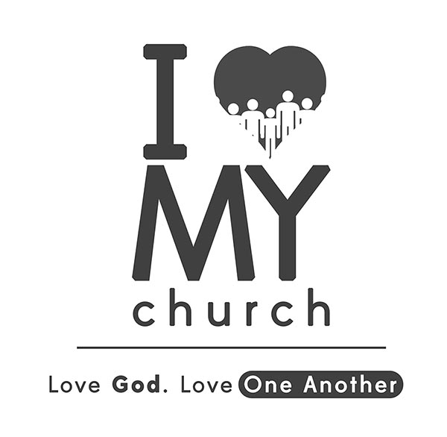
“I Love My Church”
Learning to Care for One Another!
Part 4
“The Understanding! –Accept One Another”
“Accept one another, then, just as Christ accepted you, in order to bring praise to God.” Romans 15:7

A. one another…
- Accept: In the Greek, accept means “to receive kindly or hospitably” and “to with kindness.” “To receive wholeheartedly, to warmly welcome, to grant admission into your heart, to look beyond anything superficial and to be willing and open to build relationships.” Acceptance means to welcome someone who is different from you.
- “Accept one another, as Christ accepted you…”
- “Accept one another, just as Christ accepted you, in order to bring to God.”
- When the body of Christ, like the body of Christ, the world believes the message of Christ.

- …
“Be kind and compassionate to one another, forgiving each other, just as in Christ God forgave you.” Ephesians 4:32

- Acceptance is , compassionate and forgiving. (There can be a harsh, unkind spirit when we are fearful of losing benchmarks of our faith or losing our standards. Let God protect those.)
“Therefore let us stop passing judgment on one another. Instead, make your mind not to put any stumbling block or obstacle in the way of a brother or sister.” Romans 14:13
- Acceptance is not . (Notice that in Romans 14, Paul does not tell us who is right or wrong but the encouragement to accept one another. To create that safe environment for differences.)
“Don’t grumble against one another, brothers and sisters, or you will be judged. The Judge is standing at the door!” James 5:9
- Acceptance does not against one another. (Both parties have a right to their belief and guarding our spirit is the most significant issue at stake! We can stand for the right thing in the wrong way and be absolutely wrong!)
“Brothers and sisters, do not slander one another. Anyone who speaks against a brother or sister or judges them speaks against the law and judges it. When you judge the law, you are not keeping it, but sitting in judgment on it.” James 4:11
- Acceptance does not . (Acceptance doesn’t pit oneself against others or one’s position against others in a battle of “I am better than…”. Protecting one another, loving one another, lifting up one another are our standards as followers of Jesus.)

- Acceptance gives room for …
“In essentials, unity; non-essentials, liberty, in all things, charity.”
- Within the Word of God, there is right, wrong, and personal .
- Within the Word of God, there are biblical principles and personal .
- Biblical principles change and are the same for all of us.
- Personal convictions (or disputable matters) may change and be different for all of us.
“Accept the one whose faith is weak, without quarreling over disputable matters.” Romans 14:1

- So…how do we agree to and accept one another?
- yourselves to stop judging! Treat judging like a temptation and instead of judging, change your thinking.
“Therefore let us stop passing judgment on one another. Instead, make your mind not to put any stumbling block or obstacle in your brother’s way.” Romans 14:13
- Give for differences of opinion…i.e. entertainment, parenting, education, political, etc.
“One man’s faith…One man considers…another man considers…”
- Do what is for everyone.
“Let us therefore make every effort to do what leads to peace and to mutual edification.” Romans 14:19
- Make it your to live to glorify God and to please Him…not yourself or others!
“We who are strong ought to bear with the failings of the weak and not to please ourselves…if we live, we live to the Lord; and if we die, we die to the Lord. So, whether we live or die, we belong to the Lord…Accept one another, then, just as Christ accepted you, in order to bring praise to God.” Romans 15:1; 14:8; 15:7

