September 7, 2014

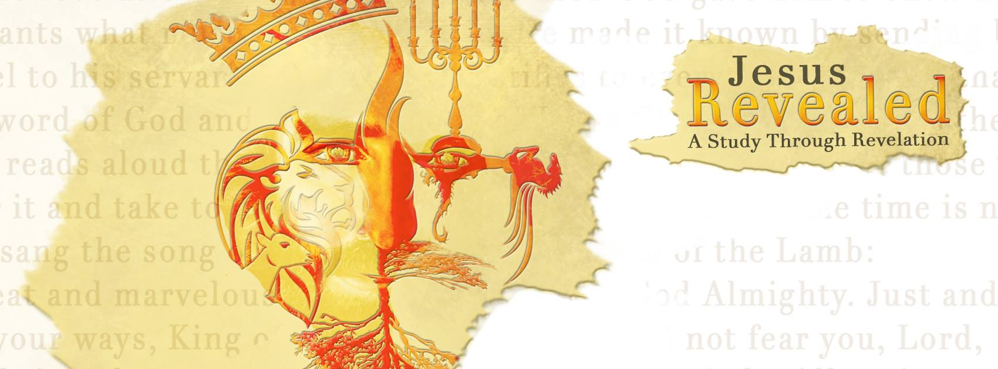 “Jesus Revealed – A Study Through Revelation” Heaven…Chapters 21 & 22
“A Forever Place” Part 2
“Then I saw a new heaven and a new earth…” Revelation 21:1a

A new heaven and a new earth are formed, then a New Jerusalem …
“I saw the Holy City, the new Jerusalem…”
- The only eternal will appear!
“I saw the Holy City, the new Jerusalem, coming down out of heaven from God, prepared as a bride beautifully dressed for her husband.”
- This new city will be the of Heaven!
“…the Holy City…”
- A dwelling place for all those who have trusted Christ by faith and have been !
“And I heard a loud voice from the throne saying, ‘Now the dwelling of God is with men, and he will live with them. They will be His people, and God Himself will be with them and be their God.’”
- The city will be a place of eternal !
“…No eye has seen, no ear has heard, no mind has conceived what God has prepared for those who love Him.” 1 Corinthians 2:9

- Jesus is making everything …
“He who was seated on the throne said, ‘I am making everything new!’…for the old order of things has passed away.”
- Jesus will wipe away every from our eyes.
“He will wipe every tear from their eyes.”
- All the reasons for tears will be !
“…no more death or mourning or crying or pain…”
- God reassures us once again of His character and His eternal power and majesty!
“…these words are trustworthy and true…It is done. I am the Alpha and the Omega, the Beginning and the End.”
- In spite of His incredible, awesome , He still personally invites us into that eternal relationship with Him!
“To him who is thirsty I will give to drink without cost from the spring of the water of life. He who overcomes will inherit all this, and I will be his God and he will be my son.”

- In spite of the Glory of God…there is always the reminder that the sacrifice of Christ and the receivers of His grace are the only into this glory…
“But the cowardly, the unbelieving, the vile, the murderers, the sexually immoral, those who practice magic arts, the idolaters and all liars- their place will be in the fiery lake of burning sulfur. This is the second death.”
- The of eternal choices will come to all.
- The second will be a reality for those who have not been overcomers.
- It is impossible for God to His promises without the realization of those who will not share in those promises.
- Although God is helping us to see eternal consequences, he is still offering the of life…Jesus!
“I will give to drink without cost from the spring of the water of life.”

- The Holy City will…
- Have a brilliance like a very costly stone as clear as jasper.
- Have a great and high wall, with 12 gates guarded by an angel at each one.
- The names of the 12 tribes of Israel will appear on the gates.
- Three gates on each of the four sides of the city.
- Walls of the city with 12 foundation stones, and on them are the names of the 12 apostles of the Lamb.
- A cube measuring 1500 miles wide, 1500 miles long, and 1500 miles high.
- A wall is made out of jasper.
- Be pure gold, like clear glass.
- Have foundation stones of the city wall that are made from the following precious stones; jasper, sapphire, chalcedony, emerald, sardonyx, sardius, chrysolite, beryl, topaz, chrysoprase, jacinth, and amethyst.
- Have 12 gates that are 12 pearls; each one of the gates is a single pearl.

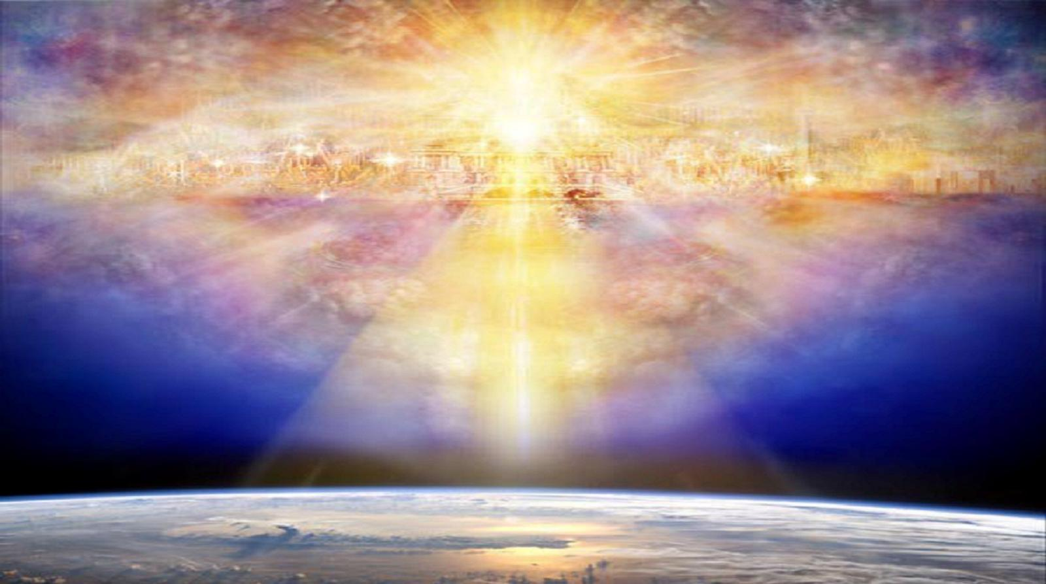
*Duncan Long

- Just think…
“People swear by someone greater than themselves, and the oath confirms what is said and puts an end to all argument. Because God wanted to make the unchanging nature of his purpose very clear to the heirs of what was promised, he confirmed it with an oath. God did this so that, by two unchangeable things in which it is impossible for God to lie, we who have fled to take hold of the hope set before us may be greatly encouraged. We have this hope as an anchor for the soul, firm and secure. It enters the inner sanctuary behind the curtain, where our forerunner, Jesus, has entered on our behalf. He has become a high priest forever, in the order of Melchizedek.” Hebrews 6:16-20

“Now if we are children, then we are heirs—heirs of God and co-heirs with Christ, if indeed we share in his sufferings in order that we may also share in his glory.” Romans 8:17
1. Every promise He has given is “trustworthy and !”
2. God wanted to make his nature and clear
to each of us.
3. God’s Word is always !
4. This hope is an and holds our soul firm!
5. Only Jesus could make this possible for us.
6. He became our Priest!
7. He invites us to be with Christ!

Revelation Summary:
Chapter 1 – A Picture of Jesus Christ
Chapter 2/3 – Letters to the Churches
Chapter 4/5 – A Look into Heaven
Chapter 6/7 – Judgments Begin
Chapter 8-10 – Judgments Continue
Chapter 11-13 – Three Key Figures
Chapters 14-16 – Angels and the Final Set of Judgments
Chapters 17-19a – Coming to the End with a Mighty Cheer!
Chapters 19b-20 – The Victor’s Return and The
Thousand Years!
Chapters 21-22 - Heaven
Next Sermon Series: “Finding My Fit”
Sept 21, 28; Oct 12, 19,26
Guest Speakers for fall:
Shirley Duncan on October 5
Christopher Yuan on November 1-2
“Out of a Far Country: A gay son’s journey to God; A broken mother’s search for hope”
Dr. Karl and Anita Eastlack December 14

