August 31, 2014

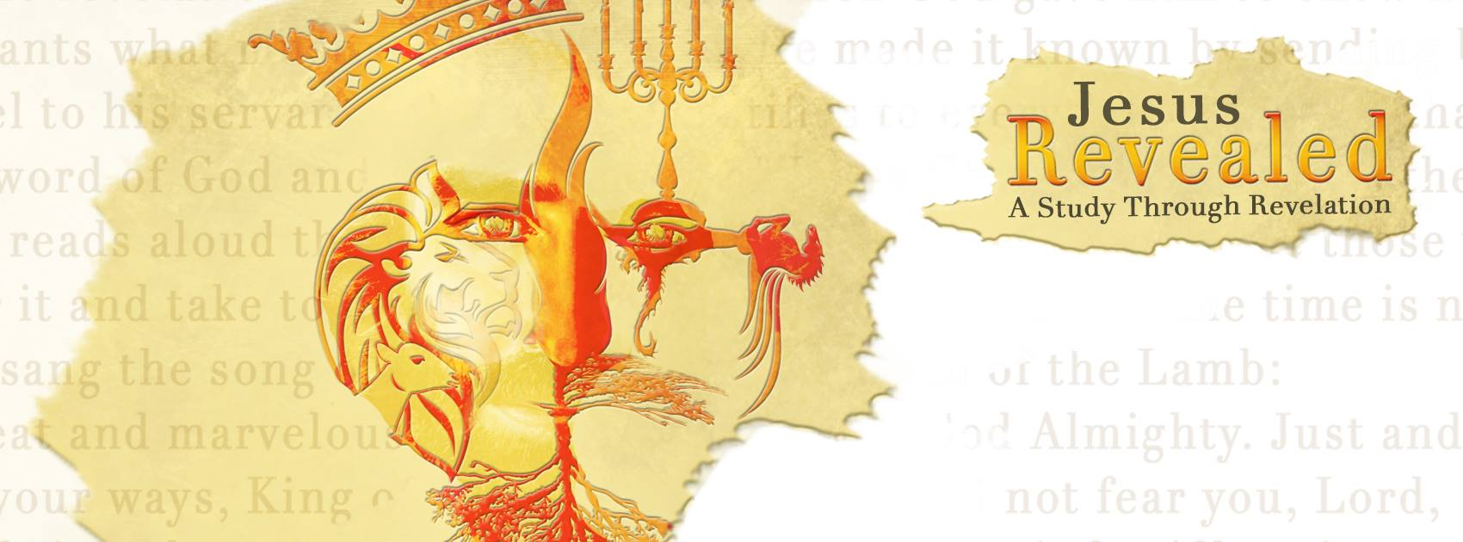 “Jesus Revealed – A Study through Revelation” Heaven…Chapters 21 & 22
“A Forever Place” Part 1
“Then I saw a new heaven and a new earth…” Revelation 21:1a

The heaven God …
“Then I saw a new heaven and a new earth, for the first heaven and the first earth had passed away, and there was no longer any sea.”
- The first two chapters of Genesis and the last two chapters of Revelation with creation of heaven and earth.
“In the beginning God created the heavens and the earth.” Genesis 1:1
- The heaven is the atmosphere above us.
“Again he prayed, and the heavens gave rain, and the earth produced its crops.” James 5:18
- The heaven is the stellar heaven; the sun, moon and stars.
“Immediately after the anguish of those days, the sun will be darkened, the moon will give no light, the stars will fall from the sky, and the powers in the heavens will be shaken.” Matthew 24:29
- The heaven is where God resides.
“I know a man in Christ who fourteen years ago was caught up to the third heaven. Whether it was in the body or out of the body I do not know—God knows. And I know that this man—whether in the body or apart from the body I do not know, but God knows—was caught up to paradise. He heard inexpressible things, things that man is not permitted to tell.” 2 Corinthians 12:2-4

- God gives us a of our future…
“Brothers, we do not want you to be ignorant about those who fall asleep, or to grieve like the rest of men, who have no hope…Therefore encourage each other with these words.” 1 Thessalonians 4:13,18
- When we die, we will immediately go to a of heaven or hell.
“We are confident, I say, and would prefer to be away from the body and at home with the Lord.” 2 Corinthians 5:8
- When we die, there is a separation and some type of judgment to determine our of residence.
“The time came when the beggar died and the angels carried him to Abraham’s side. The rich man also died and was buried. In hell, where he was in torment…” Luke 16:22,23
- When we die, we will not go to heaven where we will live .
“Then I saw a new heaven and a new earth…”
- When we die, we will with Christ forever.
“Jesus answered him, ‘I tell you the truth, today you will be with me in paradise.’” Luke 23:43

- Our lives on earth are …
“just as man is destined to die once, and after that to face judgment,” Hebrews 9:27
- Death is the end of life in our body.
“Do not be afraid of those who kill the body but cannot ill the soul. Rather, be afraid of the One who can destroy both soul and body in hell.” Matthew 10:28
- In this place of eternity, we will be able to experience the joys and of the physical body.
“In hell, where he was in torment, he looked up and saw Abraham far away, with Lazarus by his side. Se he called to him, ‘Father Abraham have pity on me and send Lazarus to dip the tip of his finger in water and cool my tongue, because I am in agony in this fire.’” Luke 16:23,24
- In this place of eternity, we will have the to remember and to see.
“But Abraham replied, ‘Son, remember…he looked up.’” Luke 16:25
- In this place of eternity, it is a place of no .
“So that those who want to go from here to you cannot, nor can anyone cross over from there to us.” Luke 16:26

- Our is in heaven…
“The creation waits in eager expectation for the sons of God to be revealed…We know that the whole creation has been groaning as in the pains of childbirth right up to the present time.” Romans 8:19,22
- All of creation has been equipped with a longing for the of Christ.
“The creation waits…” Romans 8: 19
- Our ability to understand all of this at the present time is .
“Now we see but a poor reflection as in a mirror; then we shall see face to face. Now I know in part; then I shall know fully, even as I am fully known.” 1 Corinthians 13:12
- As our hearts near to God, we develop a longing for him…a kind of homesickness for heaven!
“Instead, they were longing for a better country—a heavenly one. Therefore God is not ashamed to be called their God, for he has prepared a city for them.” Hebrews 11:16
“Meanwhile we groan, longing to be clothed with our heavenly dwelling,” 2 Corinthians 5:2
“Now there is in store for me the crown of righteousness, which the Lord, the righteous Judge, will award to me on that day—and not only to me, but also to all who have longed for his appearing.”
2 Timothy 4:8
- For those who have , death will bring us into the presence of the Lord.
“For to me, to live is Christ and to die is gain.” Philippians 1:21

Revelation Summary:
Chapter 1 – A Picture of Jesus Christ
Chapter 2/3 – Letters to the Churches
Chapter 4/5 – A Look into Heaven
Chapter 6/7 – Judgments Begin
Chapter 8-10 – Judgments Continue
Chapter 11-13 – Three Key Figures
Chapters 14-16 – Angels and the Final Set of Judgments
Chapters 17-19a – Coming to the End with a Mighty Cheer!
Chapters 19b-20 – The Victor’s Return and The
Thousand Years!
Chapters 21-22 - Heaven
Next Sermon Series: “Finding My Fit”
Sept 21, 28; Oct 12, 19, 26
Guest Speakers for fall:
Shirley Duncan on October 5
Christopher Yuan on November 1-2
“Out of a Far Country: A gay son’s journey to God; A broken mother’s search for hope”
Dr. Karl and Anita Eastlack December 14

