July 20, 2014

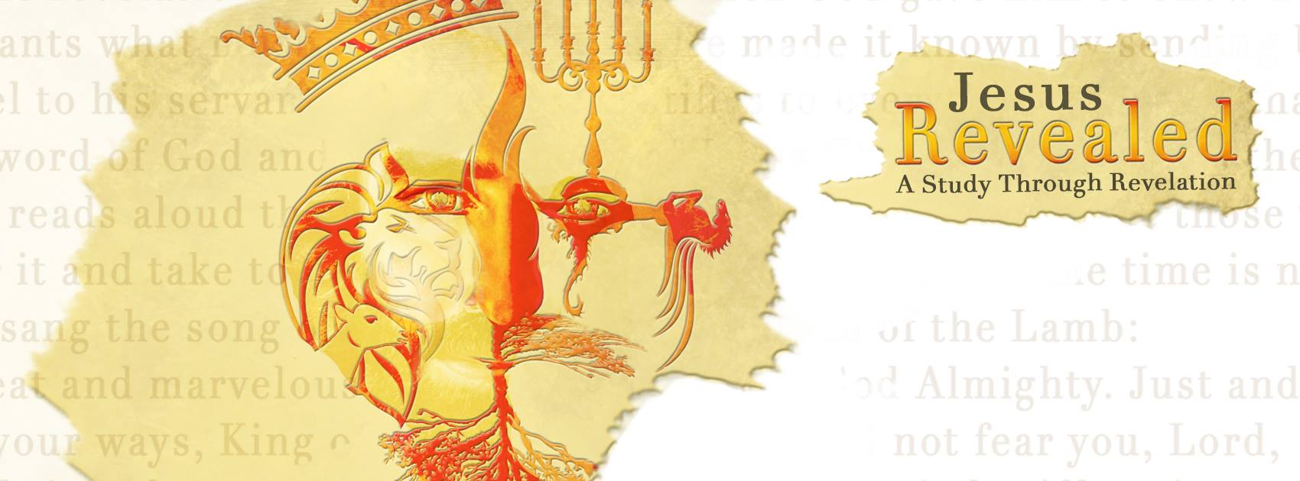 “Jesus Revealed – A Study through Revelation” Judgments Continued…Chapters 8/9/10
“No Longer Withheld”
“And he swore by him who lives for ever and ever, who created the heavens and all that is in them, the earth and all that is in it, and the sea and all that is in it, and said, “There will be no more delay!” Revelation 10:6

The judgments …
- There was for half an hour.
- There were seven judgments. The trumpet was a symbol of God’s intervention into history and always associated with “The Day of the Lord.”
- The trumpet could be a sound of , a fanfare for royalty or a summons to battle!

- The seven trumpet judgments …
“Then the seven angels who had the seven trumpets prepared to sound them.” Revelation 8:6
- The first trumpet sounds and there is and fire mixed with blood hurled upon the earth.
- The second trumpet sounds and a mountain is thrown into the sea, destroying 1/3 of sea creatures, 1/3 of the ships and turning 1/3 of the sea to blood.
- The third trumpet sounds and a great, blazing star falls into 1/3 of the waters, turning them and deadly.
- The fourth trumpet sounds darkening 1/3 of the sun, moon and .
- The fifth trumpet sounds with a falling star that releases scorpion stinging locusts torturing all those without the of God for five months.
- The sixth trumpet sounds and four were released destroying 1/3 of mankind through battle with fire, smoke, and sulfur. There will be an army of 200 million.
- But…still…they did not !
“The rest of mankind who were not killed by these plagues still did not repent of the work of their hands; they did not stop worshiping demons, and idols of gold, silver, bronze, stone and wood—idols that cannot see or hear or walk. ²¹ Nor did they repent of their murders, their magic arts, their sexual immorality or their thefts.” Revelation 9:20-21

- A mighty from heaven…
“Then I saw another mighty angel coming down from heaven. He was robed in a cloud, with a rainbow above his head; his face was like the sun, and his legs were like fiery pillars.” Revelation 10:1
- A mighty angel came straight from the presence of God and the Risen Christ robed with a cloud, rainbows and the sun, showing the of God.
- His voice like the roar of the lion or of God.
- His size and power is shown by one foot on the sea and one on the land. He stands just as firm on both.
- He carries a small scroll or but John is told not to reveal it just as Paul in 2 Corinthians 12:4.
- The of the angel is “There will be no more delay! But in the days when the seventh angel is about to sound his trumpet, the mystery of God will be accomplished, just as he announced to his servants the prophets.”

- A message to ...
“Go, take the scroll that lies open in the hand of the angel who is standing on the sea and on the land.” Revelation 10:8b
- “Go, take the scroll” The command is given but John must to the invitation voluntarily. God will not force his will on any man!
- “Take and eat it.” The invitation is to all to receive the message of God into their lives.
- “It will turn your stomach sour, but in your mouth it will be as sweet as honey.” This is a and a bitter message similar to Ezekiel and Jeremiah in the Old Testament.
- When we follow Christ, we will find our lives filled with both sweet and bitter experiences. Be prepared for and the power of God will sustain you!

So…
let the trumpet sound…
and be ready for his return!

"But do not forget this one thing, dear friends: With the Lord a day is like a thousand years, and a thousand years are like a day. The Lord is not slow in keeping his promise, as some understand slowness. Instead he is patient with you, not wanting anyone to perish, but everyone to come to repentance. But the day of the Lord will come like a thief. The heavens will disappear with a roar; the elements will be destroyed by fire, and the earth and everything done in it will be laid bare.” 2 Peter 3:8-10

“Now, brothers and sisters, about times and dates we do not need to write to you, for you know very well that the day of the Lord will come like a thief in the night. While people are saying, “Peace and safety,” destruction will come on them suddenly ,as labor pains on a pregnant woman, and they will not escape. But you, brothers and sisters, are not in darkness so that this day should surprise you like a thief.” 1 Thessalonians 5:1-4

“According to the Lord’s word, we tell you that we who are still alive, who are left until the coming of the Lord, will certainly not precede those who have fallen asleep. For the Lord himself will come down from heaven, with a loud command, with the voice of the archangel and with the trumpet call of God, and the dead in Christ will rise first. After that, we who are still alive and are left will “be caught up together with them in the clouds to meet the Lord in the air. And so we will be with the Lord forever. Therefore encourage one another with these words.” 1 Thessalonians 4:15-18

“Live such good lives among the pagans that, though they accuse you of doing wrong, they may see your good deeds and glorify God on the day he visits us.” 1 Peter 2:12

“not giving up meeting together, as some are in the habit of doing, but encouraging one another—and all the more as you see the Day approaching.” Hebrews 10:25

“And now, dear children, continue in him, so that when he appears we may be confident and unashamed before him at his coming.” 1 John 2:28

