July 6, 2014

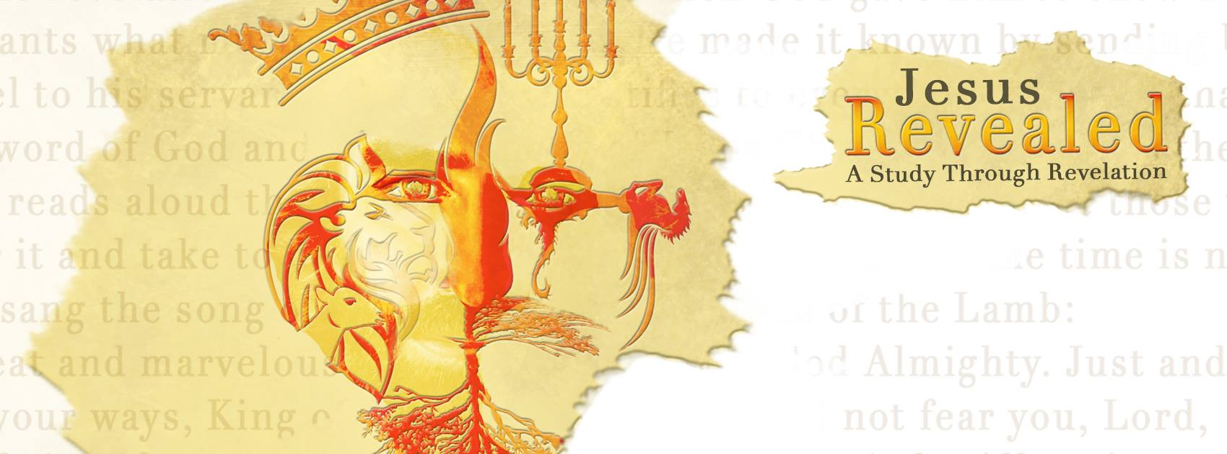 “Jesus Revealed – A Study Through Revelation” A Look into Heaven…Chapter 4/5
“Only One Is Worthy”
“‘Holy, holy, holy is the Lord God Almighty, who was, and is, and is to come.’” Revelation 4:8b

Heaven _______…
- The centerpiece of all heaven…The _________!
- Surrounded by 24 thrones with 24 ________.
- In the center were _____ living creatures…like a lion, like an ox, like a man, and like a flying eagle…each creature was covered with eyes and had six wings. Day and night they never stop saying:
“Holy, holy, holy is the Lord God Almighty, who was, and is, and is to come.”
- The 24 elders lay their _______ before the throne saying:
“You are worthy, our Lord and God, to receive glory and honor and power, for you created all things, and by your will they were created and have their being.”

- The __________________…
“Who is worthy to break the seals and open the scroll?”
- No one in heaven, or on the earth, or under the earth is ___________.
- Only one is worthy to open the scroll. He is the One who carries the and the One who carries the power.
- The 24 elders and the four living creatures, each with a harp and a golden bowl full of incense (the prayers of the saints) fell down before the in worship.
- They all join together in singing:
“You are worthy to take the scroll and to open its seals,
because you were slain, and with your blood you purchased
for God persons from every tribe and language and people and nation. You have made them to be a kingdom and priests to serve our God, and they will reign on the earth.”
- Over 100 million begin singing:
“Worthy is the Lamb, who was slain, to receive power and wealth and wisdom and strength and honor and glory and praise!”
- Then living creature begins singing:
“To him who sits on the throne and to the Lamb be praise and honor and glory and power, for ever and ever!”

- So what is heaven ?
“What no eye has seen, what no ear has heard, and what no human mind has conceived—the things God has prepared for those who love him—“ 1 Corinthians 2:9
- Heaven is filled with awesome color and .
“And the one who sat there had the appearance of jasper and ruby. A rainbow that shone like an emerald encircled the throne.” Revelation 4:3
- Heaven is dominated by one celebratory theme, and that is !
“‘See, the Lion of the tribe of Judah, the Root of David, has triumphed. He is able to open the scroll and its seven seals.’ Then I saw a Lamb, looking as if it had been slain, standing at the center of the throne, encircled by the four living creatures and the elders.” Revelation 5:5b-6a
- Heaven is filled with …music…praise… and singing!

“Holy, holy, holy is the Lord God Almighty, who was and is, and is to come.”

“You are worthy, our Lord and God, to receive glory and honor and power, for you created all things, and by your will they were created and have their being.”

“You are worthy to take the scroll and to open its seals,
because you were slain, and with your blood you purchased
for God persons from every tribe and language and people and nation. You have made them to be a kingdom and priests to serve our God, and they will reign on the earth.”

“Worthy is the Lamb, who was slain, to receive power and wealth and wisdom and strength and honor and glory and praise!”

“To him who sits on the throne and to the Lamb be praise and honor and glory and power, for ever and ever!”

“Aim at heaven and you will get earth thrown in. Aim at earth and you get neither.” – C.S. Lewis
“Surely it is not wrong for us to think and talk about Heaven. I like to find out all I can about it. I expect to live there through all eternity. If I were going to dwell in any place in this country, if I were going to make it my home, I would inquire about its climate, about the neighbors I would have — about everything, in fact, that I could learn concerning it. If soon you were going to emigrate, that is the way you would feel. Well, we are all going to emigrate in a very little while. We are going to spend eternity in another world. … Is it not natural that we should look and listen and try to find out who is already there and what is the route to take?” –D.L. Moody

