June 22, 2014

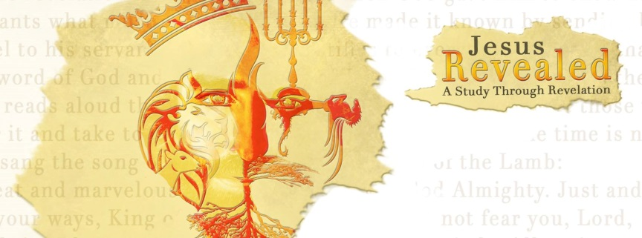 “Jesus Revealed – A Study through Revelation” Letters to the Churches…Chapter 2/3
“The Overcomer’s Reward”
“‘To him who overcomes, I will give the right to eat from the tree of life, which is in the paradise of God.’” Revelation 2:7b

There are 7 churches which received letters from

…
- These were direct letters to 7 churches.
- These have application to all of us.
- Some have said they represent 7 different .

- Each letter has a similar …
- They begin with a greeting and a commendation of their works.
- There is a condemnation of their .
- There is a challenge or .
- There is an Overcomer’s !

- Each church has a …
- Ephesus – “First Love”
- Smyrna – “Suffering or Persecution” and has no condemnation.
- Pergamum – “Satan’s Throne”
- Thyatira – “Jezebel’s Teaching”
- Sardis – “Dead” and has very little commendation.
- Philadelphia – “Faithful” and has no condemnation.
- Laodicea – “Lukewarm”

- The of Ephesus (Revelation 2:1-7)…
- There once was ; there once was vitality; there are great investments in the Kingdom without growing weary.
- But…you have lost your love!
- Remember… …and do…

- What is an ?
The overcomer is one who is walking in victory and conquering, by faith, in the “Conqueror!”
“I have told you these things, so that in me you may have peace. In this world you will have trouble. But take heart! I have overcome the world.” John 16:33
“You, dear children, are from God and have overcome them, because the one who is in you is greater than the one who is in the world.” 1 John 4:4
“for everyone born of God overcomes the world. This is the victory that has overcome the world, even our faith. ⁵ Who is it that overcomes the world? Only the one who believes that Jesus is the Son of God.” 1 John 5:4-5
“always thanking the Father. He has enabled you to share in the inheritance that belongs to his people, who live in the light. ¹³ For he has rescued us from the kingdom of darkness and transferred us into the Kingdom of his dear Son,” Colossians 1:12-13
“But whatever I am now, it is all because God poured out his special favor on me—and not without results. For I have worked harder than any of the other apostles; yet it was not I but God who was working through me by his grace.” 1 Corinthians 15:10
“Dear friends, you always followed my instructions when I was with you. And now that I am away, it is even more important. Work hard to show the results of your salvation, obeying God with deep reverence and fear. For God is working in you, giving you the desire and the power to do what pleases him.” Philippians 2:12-13
“But thanks be to God, who always leads us as captives in Christ’s triumphal procession and uses us to spread the aroma of the knowledge of him everywhere.” 2 Corinthians 2:14

- The Overcomer’s …
1. The Overcomer will eat from the of life in Paradise. Rev. 2:7
2. The Overcomer will receive the Crown of Life and not be hurt by the second . Rev. 2:10,11
3. The Overcomer will receive the hidden manna and get a white stone with a that is particular to each of us! Rev. 2:17
- The Overcomer will be given authority over nations and will receive the morning . Rev. 2:26-28
- The Overcomer will be dressed in white, will not blot his name out of the Book of , and will acknowledge his name before the Father. Rev. 3:5.
- The Overcomer will be made a in the temple of God with the names of God, the city of God, the new Jerusalem, and my new name all inscribed. Rev. 3:12
- The Overcomer will be given the right to sit with Jesus on his !! Rev. 3:21

“He who has an ear, let him hear what the Spirit says to the churches.” Revelation 3:22

“Here I am! I stand at the door and knock. If anyone hears my voice and opens the door, I will come in and eat with him, and he with me.” Revelation 3:20

