June 8, 2014

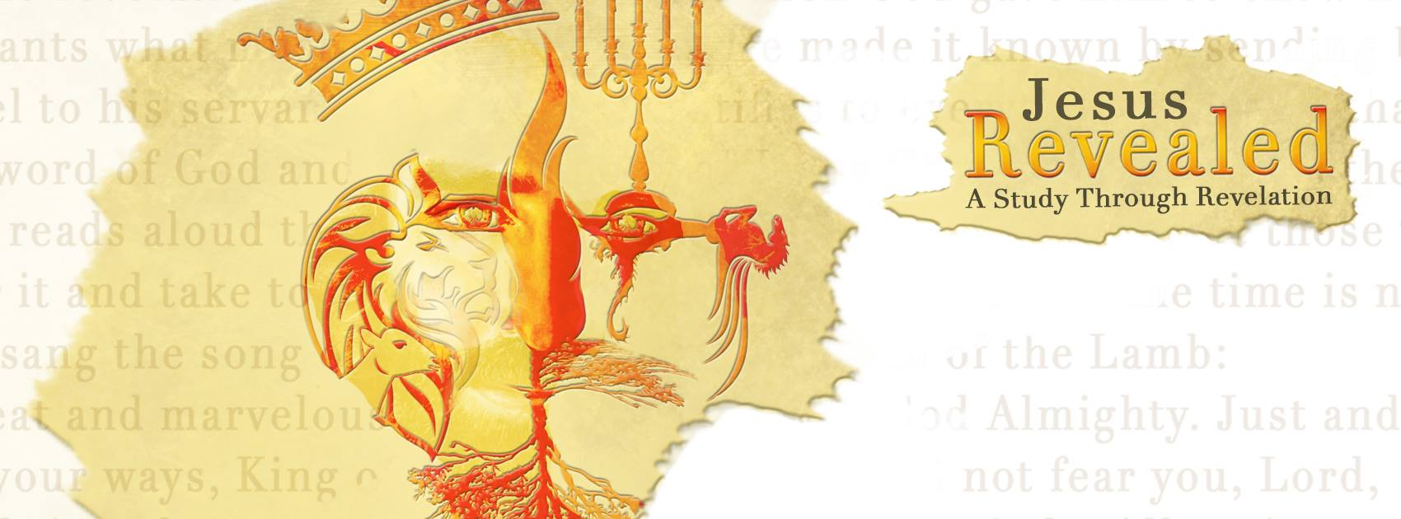 “Jesus Revealed –
A Study Through Revelation” A Picture of Christ…Chapter 1”
“‘I am the Alpha and the Omega,’ says the Lord God, ‘who is, and who was, and who is to come, the Almighty.’” Revelation 1:8

The message of Revelation…
- It is the only book of the New Testament.
- It is the only other “ ” book.
- It is a book of …”soon”, “near”…
- It is a book that is hard to .
- It is a book that is easily .
- It is full of the Old Testament; mentioned over times in 404 verses.
- It is written by the closest of Jesus upon receiving this revelation!

- The that comes with Revelation…
- A blessing comes to those who this book.
- A blessing comes to those who the reading of this book.
- A blessing comes to those who or obey the words of this book.

- The picture of Christ that Revelation gives us as God’s messenger…
- “His head and his hair were white like wool” representing his divine .
- “His eyes were like blazing fire” piercing through the of man.
- “His feet were like bronze glowing in a furnace” meaning and speed.
- “His voice was like the sound of rushing waters” both thunderous and .
- “In His right hand he held seven stars” with the strength to uphold the heavens and
to wipe away tears.
- “Out of His mouth came a sharp double-edged sword” with the penetrating quality of the Word of God to man’s heart and thoughts.
- “His face was like the sun shining in its brilliance” with the radiance and the glory of God that no human could fully !

“When I saw him, I fell at his feet as though dead. Then he placed his right hand on me and said: ‘Do not be afraid. I am the First and the Last. I am the Living One; I was dead, and behold I am alive for ever and ever! And I hold the keys of death and Hades. Write, therefore, what you have seen, what is not and what will take place later.’” Revelation 1:17-19

- What does Jesus want us to ?
- Be !
“[ Epilogue: Invitation and Warning ] ‘Look, I am coming soon! My reward is with me, and I will give to each person according to what they have done.’” Revelation 22:12
- Be !
“After that, we who are still alive and are left will be caught up together with them in the clouds to meet the Lord in the air. And so we will be with the Lord forever. Therefore encourage one another with these words.” 1 Thessalonians 4:17-18
- Be !
“ You also must be ready, because the Son of Man will come at an hour when you do not expect him.” Luke 12:40

“‘Look, he is coming with the clouds,’ and ‘every eye will see him, even those who pierced him’; and all peoples on earth ‘will mourn because of him.’ So shall it be! Amen. ‘I am the Alpha and the Omega,’ says the Lord God, ‘who is, and who was, and who is to come, the Almighty.’” Revelation 1:7-8

